Model Grant of

Fishing & Boating Access Easement

A legal instrument for establishing public access to waterways for fishing, boating or other recreational and educational uses

Prepared by the

Pennsylvania Land Trust Association

with support from the

William Penn Foundation

and the Growing Greener programs of the

Pennsylvania Department of
Environmental Protection

and the

Pennsylvania Department of
Conservation and Natural Resources
Bureau of Recreation and Conservation

Find the most recent edition of this document as well as other models and guidance at ConservationTools.org and ConserveLand.org.

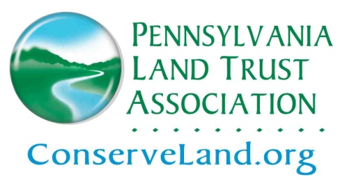

Model last updated – 6/29/2011

Introduction
The Model Grant of Fishing & Boating Access Easement provides users with a state-of-the-art legal instrument for establishing public access to waterways for fishing, boating or other recreational and educational uses. The model may be customized to provide a level of access consistent with the needs of the landowner and the goals of the nonprofit organization or government body seeking to establish access.
If users also wish to protect the riparian resources that make public access desirable, the model may be used in conjunction with the Model Riparian Buffer Protection Agreement or the Model Grant of Conservation Easement. Section 5.07 of the commentary to each of these models provides instructions for linking the public access easement to the respective resource protection easement.
The model utilizes the commentary of the Model Trail Easement Agreement with which it shares a development platform. Users are strongly encouraged to review the commentary to understand the reasoning behind the provisions in the model. The commentary also covers alternative and optional provisions.

Comments Requested
The Pennsylvania Land Trust Association welcomes suggestions for improving the model. Please share potential optional and alternative provisions and identify issues in need of investigation. Comments may be directed to Andy Loza at aloza@conserveland.org.

Related Guidance
The Pennsylvania Land Trust Association develops and maintains guides that can assist in establishing public access easements and managing public access. Among the resources posted at ConservationTools.org is the guide Reducing Liability Associated with Public Access.
Suite of Model Documents
The Pennsylvania Land Trust Association develops and maintains model legal documents and commentaries to assist landowners, conservation organizations and governments in completing conservation transactions:
Conservation Easements
- Model Riparian Buffer Protection Agreement
- Model Grant of Conservation Easement

Public Access Easements
- Model Trail Easement Agreement
- Model Grant of Trail Easement
- Model Grant of Fishing & Boating Access Easement
- Model Fishing Access Agreement (hybrid conservation and public access easement)

Supporting Model Documents
- Model Mortgage Subordination
- Model Donation Memorandum
- Model Conservation Funding Covenant

Users can review and download the latest editions of these and other models at ConservationTools.org and ConserveLand.org.

Acknowledgements
Patricia L. Pregmon, Esq., is the principal author.
Andrew M. Loza is the project manager, editor and contributing author.

Support from the PA Department of Environmental Protection, the PA Department of Conservation and Recreation Bureau of Recreation and Conservation and the William Penn Foundation makes this endeavor possible.

