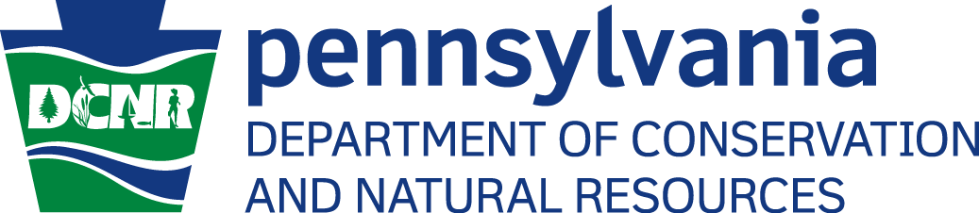

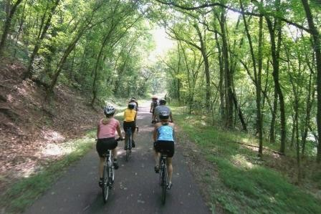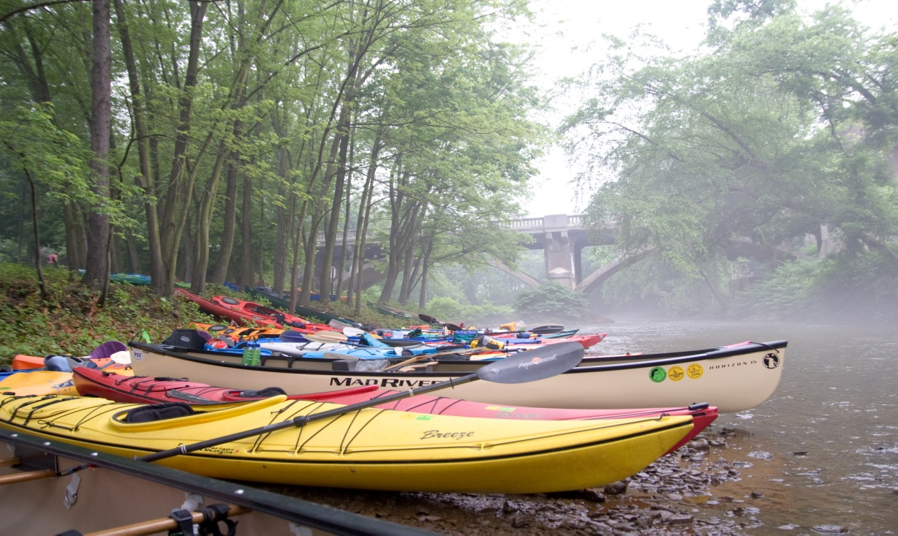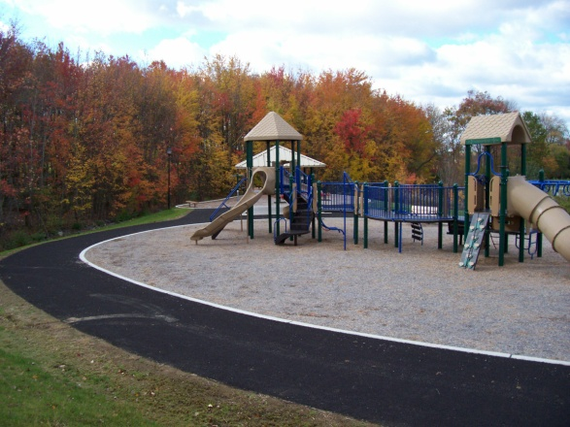
FUNDING GUIDE FOR RECREATION
AND CONSERVATION PROJECTS--March 2014

This Funding guide is a compendium of financial resources
helpful to local recreation and conservation project advocates.
This guide has been developed by DCNR’s Bureau of Recreation and Conservation (BRC) to assist communities and organizations interested in pursuing funding for their community recreation and conservation projects.

DCNR’s Bureau of Recreation and Conservation helps communities build connections between citizens and the outdoors by providing technical and financial assistance for community recreation and conservation projects and community revitalization efforts. For additional information on how BRC can assist you with your recreation and conservation project contact our Regional Offices at:

http://www.dcnr.state.pa.us/brc/aboutus/index.htm?tab=RegionalOffices#RegionalOffices

For more information on the community recreation and conservation grant program go to:

http://www.dcnr.state.pa.us/brc/grants/index.aspx

I. Parks, Trails, River Access, Open Space

- The Commonwealth Financing Agency: Greenways, Trails and Recreation Program (GTRP)
Act 13 of 2012 establishes the Marcellus Legacy Fund and allocates funds to the Commonwealth Financing Authority (the “Authority”) for planning, acquisition, development, rehabilitation and repair of greenways, recreational trails, open space, parks and beautification projects using the Greenways, Trails and Recreation Program (GTRP).

http://www.newpa.com/find-and-apply-for-funding/funding-and-program-finder/greenways-trails-and-recreation-program-gtrp

- The Conservation Easement Assistance Program provides reimbursement grants to qualified organizations to help with completing conservation as well as trail and fishing access easements, amending and restating older easements, establishing or updating baseline documentation, and installing signs on eased properties.

http://conserveland.org/ceap

- The Degenstein Foundation was created to improve the quality of life and to provide financial support to organizations with clear statements of purpose, well defined programs, and competent leadership. Thanks to the generosity of Charles B. Degenstein, the residents of central Pennsylvania will benefit forever. Special consideration is given to unique, innovative, and creative projects that benefit children, promote education, improve health care, encourage business, culture, conservation of nature resources, and protection of the environment. To be eligible for funding the applicant must be located within the region served by the foundation limited to a radius of 75 miles of Sunbury, Pennsylvania.

http://www.deg-fdn.org/

- DCNR Community Conservation Partnerships Program Grants - Environmental eGrants is an electronic grants system that provides one-stop shopping to the grantee community for all Pennsylvania Department of Environmental Protection (DEP) and Department of Conservation and Natural Resources (DCNR) grants. Environmental eGrants standardizes the application process and provides an environmentally friendly way to submit a grant application to DEP or DCNR through a secure internet connection.

https://www.grants.dcnr.state.pa.us/GrantPrograms.aspx

- National Park Service – Rivers, Trails, and Conservation. Project applicants may be state or local agencies, tribes, nonprofit organizations, or citizen groups. Federal agencies may apply in partnership with other local organizations.

http://www.nps.gov/orgs/rtca/apply.htm

- National Park Service – Chesapeake Bay Public Access - The Bay Program and its partners offer multiple grant opportunities to help fund restoration projects of all sizes across the Chesapeake watershed.

http://www.chesapeakebay.net/rfps

- PENNDOT- Transportation Alternatives Program: Moving Ahead for Progress in the 21st Century (MAP-21) introduced fundamental changes to the administration of local programs, including those that previously existed as separate programs in the Safe, Accountable, Flexible, Efficient Transportation Equity Act – A Legacy for Users (SAFETEA-LU) legislation. Transportation Enhancements (TE), Safe Routes to School (SRTS), Scenic Byways (Byways) and the Recreational Trails Program (RTP) are now consolidated into the Transportation Alternatives Program (TAP). With the exception of the RTP, which takes funding “off the top”, the current eligible activities from the SAFETEA-LU programs compete against each other for funding. Transportation alternatives projects build pedestrian and bicycle facilities, improve access to public transportation, create safe routes to school, preserve historic transportation structures, provide environmental mitigation, create trails projects that serve a transportation purpose, while promoting safety and mobility. To provide for the continuation of recreational trails projects, MAP-21 requires each State to set aside a portion of its TAP funds for projects relating to recreational trails under 23 USC 206. The program will continue to be administered by the Department of Conservation and Natural Resources (DCNR). Guidance for the Recreational Trails Program remains relatively unchanged. The remaining guidance herein is not applicable to the Recreational Trails Program, but more information is available at

http://www.dcnr.state.pa.us/cs/groups/public/documents/document/d_001241.pdf.

- The National Forest Foundation (NFF) is the only conservation organization solely focused on addressing the challenges that face America's National Forests and Grasslands. The NFF stands apart from similar organizations through its commitment to facilitating local involvement and encouraging grassroots participation in the stewardship of our public lands.

http://www.nationalforests.org/conserve/grantprograms

- PENNVEST--PENNVEST actively funds Green Initiatives that promote and encourage environmental responsibility in our communities that are creative and innovative with green solutions for water quality management. These solutions can be as simple as installation of water barrels for water collection and re-use, to regional projects that reduce sediment and nutrient contamination of the Chesapeake Bay watershed by reducing storm water runoff from agricultural areas.

http://www.portal.state.pa.us/portal/server.pt/community/programs/9322/green_initiatives/541807

- Patagonia Environmental Grants - Patagonia funds only environmental work. We are most interested in making grants to organizations that identify and work on the root causes of problems and that approach issues with a commitment to long-term change. Because we believe that the most direct path to real change is through building grassroots momentum, our funding focuses on organizations that create a strong base of citizen support.

http://www.patagonia.com/us/patagonia.go?assetid=2942

- Do GOOD Outdoors – Has $5,000 to help you use the great outdoors to do GOOD in your community. Whether you want to organize an educational trip to the tidepools, start a rock-climbing club for kids, or plant flowers in a communal garden, we want to know what you’re up to! Tell us how you’ll be doing GOOD while getting some fresh air this summer and you’ll be eligible for $5,000.

http://outdoors.maker.good.is/

- The U.S. Fish and Wildlife Service (Service) Fisheries Program’s National Fish Passage Program is a voluntary, non-regulatory conservation assistance program that provides financial and technical assistance to remove or bypass artificial barriers that impede the movement of fish and other aquatic species and contribute to their decline.

http://www.grants.gov/web/grants/view-opportunity.html?oppId=58661

- Blue moon fund is a private philanthropic foundation that makes grants to nonprofit organizations.
We work to build human and natural resilience to a changing and warming world. We use natural, social, and financial capital to implement new models in high-biodiversity regions around the world. We accept letters of inquiry solely through our website, and we accept full grant applications by invitation only. Please note that we do not accept inquiries by mail, email, or telephone.

http://www.bluemoonfund.org/grantmaking/

- Kresge Foundation - We support efforts that create access and opportunity in underserved communities. Each of our programs focuses on specific areas so we ask that you begin by learning more about the program that best fits your project.

http://kresge.org/funding/apply-for-funding

- Lawrence Foundation - The foundation is focused on making grants to support environmental, human services and other causes although our interests are fairly diverse and may lead us into other areas on an occasional basis. We make both program and operating grants and do not have any geographic restrictions on our grants. Nonprofit organizations that qualify for public charity status under section 501(c)(3) of the Internal Revenue Code or public schools and libraries are eligible for contributions or grants.

http://www.thelawrencefoundation.org/grants/guidelines.php

- The Mazda Foundation awards grants to programs promoting: education and literacy, environmental conservation, cross-cultural understanding, social welfare, and scientific research.

http://www.mazdafoundation.org/Grant_Guidelines.html

- Shell Grants will consider charitable contributions to eligible nonprofit organizations with priority consideration given to organizations serving in or near US communities where Shell has a major presence. Focus on biodiversity initiatives with support to programs that restore critical eco systems, address water, air quality research, preserve wetlands and sponsor wetlands initiatives. As part of our commitment to environmental stewardship, we support projects that restore and protect critical ecosystems. In addition to restoration and preservation efforts, we fund research projects for threatened wildlife and/or habitats.

http://www.shell.us/environment-society/grant.html

- Nathan Cummings Foundation - The Environment program's accountability approach will therefore seek to address the root causes of environmental degradation. Funding priority will be given to projects with the potential of having state, multi-state, or national impacts.

http://www.nathancummings.org/grant-programs/ecological-innovation-program

- Dr Robert C. & Tina Sohn Foundation - While the scope of the Foundation's efforts are largely centered on the environment and alternative health care modalities, the Foundation has the flexibility to contribute to such other causes as the Trustees believe are consistent with the Sohns' vision, including alleviation of poverty, education and the arts.

A. The Foundation makes grants to private and publicly supported, not-for-profit, IRC approved 501(c)(3) tax exempt agencies, institutions, and organizations.

B. The Foundation makes grants to eligible institutions whose mission involves: The Environment, Health and Human Services, Education (Arts)

http://www.sohnfoundation.org/Grant_guidelines1.htm

- M&T Bank - At M&T Bank, we recognize that our corporate success is directly related to the health and vitality of the communities we serve. So, as a corporate citizen, we believe in providing resources to not-for-profit organizations that make our communities better places to live and work. Through our philanthropic arm, The M&T Charitable Foundation, we support a diverse range of civic, cultural, education, health care, human service and youth organizations with financial grants, employee volunteerism and in-kind services

https://www.mtb.com/aboutus/community/Pages/CharitableContributions.aspx

- Wells Fargo - If your organization meets Wells Fargo’s eligibility requirements and fits in with our philanthropic goals and objectives, we encourage you to proceed with our online application. We support the improvement of low and moderate-income communities through programs that revitalize and stabilize communities and also build strong environmental practices through programs that conserve natural resources, protect endangered species and preserve the global environment.

https://www.wellsfargo.com/about/charitable/pa_guidelines

22. Joint Use Playground Grants of $15,000 and $30,000 are available to communities within the United States for the creation of joint use agreements for playground facilities. The $15,000 Joint Use Grants will support the opening of at least four playgrounds. The $30,000 Joint Use Grants will support the opening of at least eight playgrounds. Grant recipients must commit to opening the playgrounds within one year of the grant decision.

https://jointuse.myreviewroom.com/

- Tony Hawk Foundation Skate Board Park Grants -The primary mission of the Tony Hawk Foundation is to promote high quality, public skateparks in low-income areas throughout the United States. While we realize that not every area can afford to build big, expensive skateparks, we feel strongly that public skateparks should be designed and constructed by experienced contractors. We also believe that local officials should treat public skateparks the same way they treat public basketball courts or tennis courts, meaning that anyone may show up and use them anytime, unsupervised.

http://www.tonyhawkfoundation.org/skatepark-grants/apply/

II. Water Resource Protection & Clean-up

- American Canoe Club Stewardship Grant - It is not mandatory to be a paddling club to apply. In the past, grants have been awarded to conservation organizations and watershed groups. However, applications that incorporate paddling or cooperation with local paddling organizations will be given priority.

http://www.americancanoe.org/?page=LLBean_CFS_Grant

- Spent Tire Program - These grant programs provide funding for the cost of cleanup, abatement, or other remedial actions related to the disposal of waste tires collected at cleanup projects and amnesty events. California jurisdictions including cities, counties, special districts, other political subdivisions and jurisdictions joined together by formal agreements, as well as California Indian tribes are eligible to apply. Cities or counties may submit a regional application with authorization from other cities and/or counties participating in the regional application.

http://www.calrecycle.ca.gov/tires/grants/Cleanup/

- Keep America Beautiful (KAB)-- Keep America Beautiful’s partnerships with sponsors in the business community provide significant grants to our affiliates that can be used for creating and expanding local programs. These competitive grants promote volunteerism, beautification, community greening, litter prevention, recycling, waste reduction, and more. In the last few years, KAB affiliates have received grants and in-kind services valued at more than $10 million. These significant grants allow our affiliate network to further KAB’s mission to build and sustain vibrant communities.

http://www.kab.org/site/PageServer?pagename=grants_Grant_applications

- The Rite Aid Foundation is dedicated to helping people in the communities Rite Aid serves lead happier, healthier lives. Eligible programs must focus on health and wellness in the communities in which Rite Aid operates and be offered by non-profit organizations that are classified under section 501(c)(3) of the Internal Revenue Service Code. Applications are accepted throughout the year with rolling deadlines. Grants are awarded for one year at a time, and no organization can receive a grant more than two years in a row.

http://www.expandedschools.org/funding-opportunities/rite-aid-foundation#sthash.Pz20Ui6M.dpbs

- Colcom Foundation’s principal funding interests reflect a primary concern for quality of life, which it strives to address with honesty, compassion and responsibility. Through the practice of strategic grant-making, the Foundation focuses its philanthropic program on environmental sustainability, natural resource preservation, land and water conservation, and efforts to establish a sustainable population.

http://www.colcomfdn.org/interests.html

- EPA- Regional Wetland Program Development Grants
Wetland Program Development Grants (WPDGs) provide eligible applicants an opportunity to conduct and promote the coordination and acceleration of research, investigations, experiments, training, demonstrations, surveys, and studies relating to the causes, effects, extent, prevention, reduction, and elimination of water pollution.

http://www.grants.gov/web/grants/view-opportunity.html?oppId=251499

Additional information on EPA grants:

http://www.grants.gov/web/grants/home.html;jsessionid=cJFcTjqLMJL6sgmrMGVBMZl9JY0zqbgBmvyqcjlvkNYXJ2yrBLPV

- The Cora L. Brooks Foundation responds to the need for clean water. Established in 1999, the Foundation provides grants for the purpose of environmental conservation or restoration within the watersheds of the Delaware and Susquehanna Rivers, with particular emphasis on environmental protection issues relating to clean water and water related ecologies.

http://www.foundationoffices.org/

- Abandoned mine drainage (AMD) is the single largest source of pollution to waterways within the West Branch Susquehanna watershed. As a result of the extensive impact that AMD pollution has on the watershed, countless federal and state agencies, non-governmental organizations, academic institutions, watershed groups, and individuals have accepted the responsibility of addressing this problem. Moreover, there is growing recognition of the direct economic benefits to the region from tourism and recreation giving even greater impetus to restoration projects.

West Branch Susquehanna Restoration Coalition

- Commonwealth Financing Authority (CFA)—Marcellus Legacy Fund, Watershed Restoration Protection: Act 13 of 2012 establishes the Marcellus Legacy Fund and allocates funds to the Commonwealth Financing Authority for watershed restoration and protection projects. The overall goal of the Watershed Restoration and Protection Program (WRPP) is to restore, and maintain restored stream reaches impaired by the uncontrolled discharge of nonpoint source polluted runoff, and ultimately to remove these streams from the Department of Environmental Protection’s Impaired Waters list.

CFA, Marcellus Legacy Fund - Watershed Restoration Protection

- Common Wealth Financing Authority (CFA) —Marcellus Legacy Fund, Baseline Water Quality Data: Act 13 of 2012 establishes the Marcellus Legacy Fund and allocates funds to the Commonwealth Financing Authority (the “Authority”) to be used fund statewide initiatives to establish baseline water quality data on private water supplies using the Baseline Water Quality Data Program (BWQDP).

CFA, Baseline Water Quality Data

- Common Wealth Financing Authority (CFA) —Abandoned Mine Wells: Projects which involve the reclamation of Abandoned Mine Well(s), construction of a new AMD site, remediation and repair of existing AMD project sites, operation and maintenance maintaining current AMD remediation sites, establishment of trust fund to ensure ongoing maintenance is achieved, and monitoring of water quality to track or continue to trace nonpoint source load reductions resulting from AMD remediation projects.

CFA, Abandoned Mine Drainage Abatement and Treatment

12. Coldwater Heritage Partnership (CHP) : Provides leadership, coordination, technical assistance, and funding support for the evaluation, conservation and protection of Pennsylvania's coldwater streams. The Coldwater Heritage Partnership (CHP) is a collaborative effort between the PA Fish & Boat Commission, PA Department of Conservation and Natural Resources, Foundation for Pennsylvania Watersheds and Pennsylvania Trout.

Coldwater Conservation Grants Program

- WPC’s Watershed Conservation Program is dedicated to watershed conservation issues and to providing a full range of services to the community. WPC participates in a wide range of water conservation efforts including watershed conservation plans, watershed restoration projects, bathymetry initiatives, water trail mapping, algae studies and many others.

Western PA Conservancy Mini Grants

- Pennsylvania American Water is launching the Community Investment Challenge contest on Facebook this fall to give nonprofit organizations the opportunity to win grant money for their community/environmental improvement project.

PA American Water - Community Investment Challenge

15. Chesapeake Stormwater Network - Urban BMP in the Bay Award (BUBBA)
The Best Urban BMP in the Bay Award contest (BUBBA) recognizes the best urban BMPs that have been installed in the Chesapeake Bay watershed. Many other organizations have offered LID design competitions to promote the implementation and adoption of LID practices in areas where they have not previously been employed. Here, in the Chesapeake Bay watershed, LID practices are more commonly employed as a result of stringent stormwater management regulations and the recently implemented Bay TMDL. One of the things we have seen here at CSN is that local implementers tend to lead the way in trying new and innovative approaches to dealing with difficult stormwater problems.

Chesapeake Stormwater Network - Urban BMP in the Bay Award (BUBBA)

16. National Forest Foundation-- The National Forest Foundation (NFF) is the only conservation organization solely focused on addressing the challenges that face America's National Forests and Grasslands. The NFF stands apart from similar organizations through its commitment to facilitating local involvement and encouraging grassroots participation in the stewardship of our public lands.

National Forest Foundation

17. William Penn Foundation - The William Penn Foundation works to advance opportunity, foster creativity, and ensure sustainability, we will continue to honor our enduring values of stewardship, respect, integrity, collaboration, and accountability. Acting with transparency and renewed urgency, we want to use data effectively in our service to others as a smart resource and dedicated partner.

ttp://www.williampennfoundation.org/GrantmakingOverviewApplicationProcess.aspx

III. Brownfield Grants

- EPA's Brownfields Program provides direct funding for brownfields assessment, cleanup, revolving loans, and environmental job training. To facilitate the leveraging of public resources, EPA's Brownfields Program collaborates with other EPA programs, other federal partners, and state agencies to identify and make available resources that can be used for brownfields activities. In addition to direct brownfields funding, EPA also provides technical information on brownfields financing matters.

http://www.epa.gov/brownfields/grant_info/index.htm

- Brownfield’s Multi-Purpose Pilot Grants - EPA is announcing the availability of funding to nonprofit organizations and eligible entities to deliver environmental workforce development and job training programs focused on hazardous and solid waste management, assessment, and cleanup associated activities, chemical safety, and wastewater management.

http://www.epa.gov/brownfields/applicat.htm
- Public Works grants-- support the construction or rehabilitation of essential public infrastructure and facilities necessary to generate or retain private sector jobs and investments, attract private sector capital, and promote regional competitiveness, innovation, and entrepreneurship, including investments that expand and upgrade infrastructure to attract new industry, support technology-led development, accelerate new business development, and enhance the ability of regions to capitalize on opportunities presented by free trade.

https://www.cfda.gov/index?s=program&mode=form&tab=step1&id=f860a3b8eeae5e8f25a41e38e511a72c

- PENNVEST- Non-Point Source Projects -- By reducing or eliminating water quality threats to the health and welfare of Pennsylvania's citizenry and to the environment, PENNVEST anticipates that the Brownfield's remediation low-interest loan program will help facilitate the sale and reuse of industrial and commercial properties in the Commonwealth. This is an important benefit to all Pennsylvania residents. As the potential environmental liabilities of reusing or further developing existing commercial properties diminish, economic benefits are expected for both the buyer and seller. PENNVEST is optimistic that its Brownfield remediation funding initiative will provide the following benefits: improve local surface and groundwater quality; encourage reuse of property in urban areas rather than suburban sprawl into surrounding rural areas; help revitalize the economies of local communities; create employment opportunities in areas of low income and/or high unemployment; increase local tax bases; facilitate the use or reuse of existing infrastructure and facilities located in the proximity of the sites; and facilitate the creation, preservation, or addition to parks, greenways, open spaces and other recreational properties.

http://www.portal.state.pa.us/portal/server.pt/community/funding_programs/9322/non-point_source_projects/541851

IV. Environmental Education

- Pennsylvania Department of Environmental Protection (DEP) The Environmental Education Grant Program was established by the Environmental Education Act of 1993, which mandates that five percent of all pollution fines and penalties collected annually by the Department of Environmental Protection be set aside for environmental education. Since the inception of the environmental education grant program, DEP has awarded nearly $8 million in grants to support the environmental education efforts throughout Pennsylvania. Administered through DEP, the funds are used for projects ranging from creative, hands-on lessons for students, teacher training programs, and outdoor learning resources to conservation education for adults.

http://www.portal.state.pa.us/portal/server.pt/community/environmental_education/13903/grants/588549

- Pennsylvania Trout Unlimited (PATU) offers funding opportunities for teachers and partners. The grant program operates through funding provided by PATU and the Pennsylvania Fish and Boat Commission (PFBC)

Trout in the Classroom

- Lowe’s Toolbox for Education Grants - This year, as a foundation, we are challenging ourselves to seek ways to provide the tools that help our educators and parent groups through today's challenging times efficiently, while providing the greatest impact, with basic necessities taking priority.

Lowes Toolbox for Education Grants

- National Education Foundation: We support new ideas and practices to strengthen teaching and learning. Our goal is to fund and share successful strategies to educate and prepare students for bright and rewarding futures. We have learned that the best teaching methods come from our greatest assets: educators. That is why, over the last 10 years, we have awarded more than $7.1 million to fund nearly 4,500 grants to public school educators to enhance teaching and learning. To build our knowledge base and to uncover new, great practices in public education we invite all eligible educational professionals to apply for these grants. We support new ideas and practices to strengthen teaching and learning. Our goal is to fund and share successful strategies to educate and prepare students for bright and rewarding futures.

http://www.neafoundation.org/pages/grants-to-educators/

- Lexus Eco Challenge---funds life-changing opportunities for teens across the nation to make a difference in the environmental health of our planet, one community at a time.

Lexus Eco Challenges

- Chesapeake Bay Trust Mini Grant Program -- supports activities such as Meaningful Watershed Educational Experiences (MWEE), teacher professional development and programs to advance environmental literacy in the Chesapeake Bay and its rivers and streams.

http://www.cbtrust.org/site/c.miJPKXPCJnH/b.5457547/k.28ED/Mini_Grant.htm

- The Water Resources Education Network (WREN) is a project of the Citizen Education Fund of the League of Women Voters of Pennsylvania (LWVPA-CEF). WREN is a nonpartisan informal collaboration of organizations and public officials working for the protection and management of Pennsylvania’s water resources, both surface and ground water, through grass-roots education and informed policy-making. WREN provides training and grants for local coalition building to promote community awareness and development of public policies necessary to protect Pennsylvania water resources.

http://wren.palwv.org/grants/local.html

- The Lorrie Otto Seeds for Education Grant Program gives small monetary grants to schools, nature centers, and other non-profit and not-for-profit places of learning in the United States with a site available for a stewardship project. Successful non-school applicants often are a partnership between a youth group (scouts, 4-H, etc.) and a site owner. Libraries, government agencies and houses of worship are eligible subject to youth participation.

http://www.for-wild.org/seedmony.htm

V. Resource towns, community revitalization, downtown improvement, etc

- Pennsylvania Department of Conservation and Natural Resources, Bureau of Forestry Tree Vitalize- Responding to an alarming trend of the loss of trees in Pennsylvania’s metropolitan areas, TreeVitalize is a public-private partnership to help restore tree cover, educate citizens about planting trees as an act of caring for our environment, and build capacity among local governments to understand, protect and restore their urban trees.

http://www.treevitalize.net/SubGrant.aspx

- Scotts Miracle-Gro - provides GRO1000 Grassroots Grants to help foster community spirit and public service. Grassroots Grants of up to $1,500 are awarded to local communities to help bring edible gardens, flower gardens and public green spaces to neighborhoods across the United States.

http://grogood.com/GiveBackToGro/Gro1000/Grassroots#sthash.fuMtj7SK.dpuf

- Public Lands Every Day, Every Day Event Grants-Our nation’s public lands are places where we picnic, play ball, fish, fly kites, pull weeds and plant seeds. Our public lands should be safe places of natural beauty where everyone can go to lend a hand, observe nature and enjoy life. With generous support from Toyota Motor Sales USA, Inc., NEEF offered Every Day Event Grants to public land organizations, or Friends Groups, to engage their community on a public land site.

http://publiclandseveryday.org/grants/every-day-event-grants-0

- Chesapeake Bay Green Street-Green Jobs-Green Towns Initiative -The Chesapeake Bay Trust, U.S. Environmental Protection Agency, and Maryland Department of Natural Resources Green Streets collaborative effort supports the implementation of the President’s Chesapeake Bay Protection and Restoration Executive Order. It serves as a key component of the Chesapeake Bay Green Street-Green Jobs-Green Towns Initiative which supports local, grassroots-level greening efforts by towns and communities in urbanized watersheds that reduce stormwater run-off, through creation of “green streets", the increase in tree canopy, and the reduction of impervious surfaces.

http://www.cbtrust.org/site/c.miJPKXPCJnH/b.7735695/k.5E92/Green_Streets_Green_Jobs_Green_Towns.htm

- The Centers for Disease Control and Prevention (CDC), Community Transformation Grant (CTG) – Program continues its long-standing dedication to improving the health and wellness of all Americans through the Community Transformation Grant (CTG) Program. CTG is funded by the Affordable Care Act’s Prevention and Public Health Fund. CDC supports and enables awardees to design and implement community-level programs that prevent chronic diseases such as cancer, diabetes, and heart disease.

http://www.cdc.gov/nccdphp/dch/programs/communitytransformation/funds/index.htm

