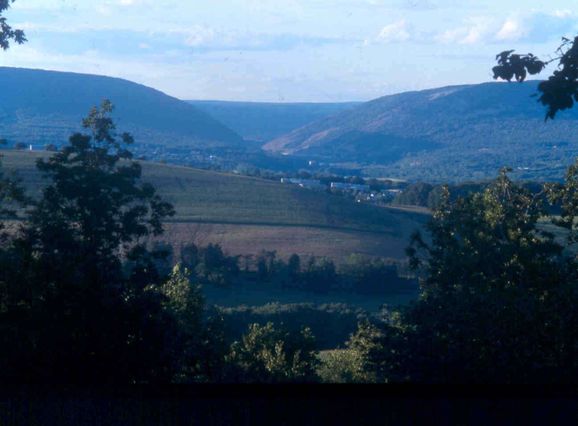

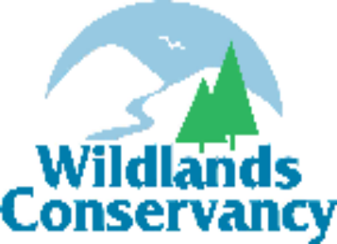
Strategic Plan 2007-2011

Table of Contents
Executive Summary 3
Acknowledgements 4
Board of Directors 5
Performance Core Values of Wildlands Conservancy 6
Vision, Mission, Goals 7
Objectives, Performance Measures, and Targets 9
Balanced Score Card 18
Timeline 26
Funding Plan 32
Core Partners ----------------------------------------------------------------------------------- 34
2007 Annual Operating Budget 36
Appendix A - Strategic Planning Process and Portfolio Analysis 38
Appendix B - Initiatives 40

Executive Summary

Wildlands Conservancy is a not-for-profit 501(c)(3), member-supported organization established in 1973 dedicated to protecting the “quality of place” in the Lehigh Valley and the Lehigh River valley in eastern Pennsylvania. Wildlands Conservancy's mission is to preserve, protect, restore, and enhance the land, water, ecological, and recreational resources of the Lehigh Valley and the Lehigh River valley. We fulfill our vision and mission through involvement with many partners in broad-based educational programs, various land-protection and stewardship strategies, science-informed water quality and ecological restoration projects, comprehensive community planning efforts, plus greenway and recreational trail development. In our 33 years of conservation activities, the Conservancy has preserved more than 45,000 acres of open space, educated more than 275,000 children and adults, developed and maintained significant trail systems, and developed and implemented several watershed-management plans. Wildlands Conservancy has a staff of 14 full- and part-time professionals and an annual operating budget of $1.6 million.
This strategic plan provides consensus and alignment of the organization’s activities. This plan, a high priority for the organization, was facilitated by an outside consultant and overseen by a board-designated committee. The document was completed with input from the staff and Board of Directors. The plan presents four major goals: 1) shelter high-priority natural, agricultural, and recreational areas in the region, and foster responsible stewardship of these assets; 2) proactively address water-quality and water-quantity issues to preserve, protect, restore, and enhance the Lehigh River and its tributaries; 3) provide educational and recreational opportunities to the community that will foster appropriate stewardship of the region’s natural treasures; and 4) ensure a viable organization. Each goal contains multiple objectives and each objective contains specific initiatives. These initiatives represent the core activities of the organization and, when completed, will enable the organization to reach its goals and fulfill its mission and vision.
This strategic plan will guide the organization and its activities for the next five years. The plan will be the foundation of the direction of the organization and help align the staff and Board with the mission and activities of Wildlands Conservancy. With this information in hand and the initiatives carried out, the organization will effectively preserve, protect, and enhance the land, water, ecological, and recreational resources of the Lehigh Valley and the Lehigh River valley.
Acknowledgements

Wildlands Conservancy would like to acknowledge the following individuals for their contributions to the creation of this strategic plan and for their on-going commitment to the preservation, protection, and enhancement of the land and water resources of the Lehigh Valley and the Lehigh River valley. Funding for the strategic plan was provided by a grant from the Pennsylvania Land Trust Alliance.
Strategic Planning Committee

Christian F. Martin, IV – Chairman
Joe H. Folger
Deirdre M. Kwiatek
Michael D. Stout
Susan L. Williams
Strategic Planning Consultant

John Rogers, Keystone Conservation Trust

Wildlands Conservancy Staff
Christopher M. Kocher, President
Dan Giannelli, Chief Operating Officer
Thomas J. Kerr, Assistant to the President
Sharon Ettinger, Director of Advancement
Debra Lermitte, Director of Land Conservation and Planning
Tom Gettings, Director of Special Projects
Brian Vadino, Director of River Program
Maureen Ruhe, Director of Environmental Education
Diane Matthews-Gehringer, Land Protection Manager
Fran Cundall, Resource Manager/Horticulturist
Denise Bauer, Staff Naturalist
Sharla Kistler, Database Manager
Renee Guzenski, Bookkeeper

Wildlands Conservancy’s
Board of Directors

Wildlands Conservancy maintains a Board of 15 highly qualified individuals. The all-volunteer Board is responsible for the strategic direction of the organization, the management of its president, and the financial viability of the organization. The staff of Wildlands Conservancy as well as the community thanks the members of the Board for their dedication and commitment to the mission of Wildlands Conservancy. The Current Board of Directors is listed below

Percy H. Dougherty, Ph.D., ex officio
Ray Erb, Jr., Ed.D.− Chair, Conservation and Education Committee
Lona Farr, Ph.D. – Chair, Committee on Directorship
Joe H. Folger – Treasurer, Chair, Finance and Investment Committee
Marc J. Grammes, ex officio
Christopher M. Kocher, ex officio
Deirdre M. Kwiatek, Ph.D. – Secretary
Christian F. Martin, IV – Chair, Strategic Planning Committee
Joan Miller Moran
Karen F. Nestor
Gloria Peter Pool
Stuart G. Rogers – Chair, Legacy Land Funds Committee
Charles J. Scagliotti, M.D.
Anthony Scarcia, Jr.
David N. Shaffer – Chairman of the Board
Michael D. Stout – Vice - Chairman of the Board
Clifford R. Trumbo, Jr. – Chair, Property and Facilities Committee
Susan L. Williams − Chair, Advancement Committee
Michael A. Henry, Esq. − Counsel
Performance Core Values of Wildlands Conservancy

These beliefs reflect Wildlands Conservancy’s perspective on the world and guide its day-to-day activities:

1. We value all life on earth and appreciate its inherent worth, beauty, and inspiration.

2. Stewardship of the earth sustains life, our economy, and our sense of being and place. It is our responsibility and legacy to future generations and the source of great enjoyment.

3. Connecting people to land fosters good stewardship and a sense of community. An educated and informed citizenry will be better stewards of the environment.

4. We respect the inherent diversity and interrelatedness of human beings and nature. What affects one affects all.

5. The prosperity and health of our economy, citizenry, and environment are directly linked to each other. To make progress in any one area, we must strive for simultaneous, sustained excellence in all.

6. Positive conservation action requires change, innovation, and creativity.

7. Transparency and accountability are fundamental to earning public trust and aligning people to achieve effective conservation success.

8. It is necessary for local leadership to drive sustained conservation success.

9 We maintain our credibility by being objective, responsive, and practical.

10. We provide our employees a safe and enjoyable place to work and strive to keep valuable
employees involved with the organization.

11. Conservation success depends upon cultivating and sustaining organizational relationships and partnerships. Different people bring different gifts and perspectives to a team. A strong team is founded on diversity.

VISION
Saving the natural treasures of the Lehigh Valley and the Lehigh River valley for now and for future generations.

MISSION
Preserve, protect, restore, and enhance the land, water, ecological, and recreational resources of the Lehigh Valley and the Lehigh River valley.

GOALS AND OBJECTIVES
I. Shelter high-priority natural, agricultural, and recreational areas in the region, and foster responsible stewardship of these assets.
A. Continue to preserve an average of 1,500 acres per year of high-priority land in the region focusing on the Blue Mountain, Lehigh River corridor, South Mountain, Natural Area Inventory Sites, working farms, and area greenways and trails.
B. Restore, repair, and upgrade the facilities and properties owned and operated by Wildlands Conservancy.
C. Identify and implement planning projects to promote the proper stewardship of our land, water, and recreational resources.

II. Proactively address water-quality and water-quantity issues to preserve, protect, restore, and enhance the Lehigh River and its tributaries.
A. Remediate the abandoned mine drainage (AMD) impacts in the Lehigh River watershed.
B. Continue to complete streambank remediation and protection projects on five critical miles of streams in the Lehigh River watershed.
C. Monitor the quality of local waterways and work to address water-quantity issues in the watershed.
III. Provide educational and recreational opportunities to the community that will foster appropriate stewardship of the region’s natural treasures.
A. Provide experiential education and awareness opportunities for school-aged children.
B. Use Pool Wildlife Sanctuary and other natural areas to provide educational opportunities that conform to the state’s educational mandates for school-age children.
C. Offer educational leadership by providing programs and services to local governments and landowners.
D. Provide experiential education and awareness opportunities for the general public.
E. Provide innovative educational programming to encourage knowledge and appreciation of nature and to foster healthy, life-affirming activities for residents and visitors.

IV. Ensure a sustainable organization with a sound financial operation.

A. Increase and diversify organizational funding.
B. Ensure a sound financial operation to provide flexibility and growth.
C. Improve the marketing of the organization’s programs and activities.
D. Develop and attract career professionals with a commitment to our principles and goals.
E. Maintain, enhance, and diversify partnerships

Objectives, Performance Measures, and Targets
The following Objectives were prioritized utilizing the process listed in Appendix A.
Goal I. Shelter high-priority natural, agricultural, and recreational areas in the region, and foster responsible stewardship of these assets.
Importance | Objective | Performance Measure | 1-Year Target | 5-Year Target
100 | A. Continue to preserve an average of 1,500 acres per year of high-priority land in the region focusing on the Blue Mountain, lands north of the Blue Mountain, Lehigh River corridor, South Mountain, NAI sites, working farms, and area greenways and trails. | Acres of land | 1,500 acres | 7,500 acres
70 | B. Restore, repair, and upgrade the facilities and properties owned and operated by Wildlands Conservancy. | Facilities condition improved and deferred maintenance | 1 major project | Pool Wildlife Sanctuary facilities repaired and restored
60 | C. Identify and implement planning projects to promote the proper stewardship of our land, water, and recreational resources. | Major projects per year | 2 major projects | 10 major projects

Goal II. Proactively address water-quality and water-quantity issues to preserve, protect, restore, and enhance the Lehigh River and its tributaries.
Importance | Objective | Performance Measure | 1-Year Target | 5-Year Target
70 | A. Remediate the abandoned mine drainage (AMD) impacts in the Lehigh River watershed. | AMD assessments in the Lehigh River watershed | Begin work on assessments | 2 assessments
70 |  | AMD implementation in the Lehigh River watershed | 1 project implemented | 2.5 projects implemented
65 | B. Continue to complete stream bank remediation and protection projects on five critical miles of streams in the Lehigh River watershed. | Miles of stream bank remediation | 1 mile of stream restored | 5 Miles of stream bank remediation
50 | C. Monitor the quality of local waterways and work to address water-quantity issues in the watershed. | Effective monitoring systems | Yearly monitoring | 5 years of monitoring data showing progress

Goal III. Provide educational and recreational opportunities to the community that will foster appropriate stewardship of the region’s natural treasures.
Importance | Objective | Performance Measure | 1-Year Target | 5-Year Target
80 | A. Provide experiential education and awareness opportunities for school-aged children. | Number of Experiential opportunities | 50 programs | From 49 to 74 per year
55 | B. Use Pool Wildlife Sanctuary and other natural areas to provide educational opportunities that conform to the state’s educational mandates for school-age children. | Children attending education opportunities at Pool Wildlife Sanctuary | 14,000 students | 18,000 students/year by 2011
55 |  | Number of educational programs presented | Over 425 programs | Over 450 programs per year
55 |  | Cost per student | $10 per student | $8 per student by 2008
50 | C. Offer educational leadership by providing programs and services to local governments and landowners. | Benchmark education tools for local government and land owners | 8 programs | 10 Programs per year
40 | D. Provide experiential education and awareness opportunities to the general public. | Benchmark public education experiential opportunities | 20 programs | 20 programs per year
15 | E. Provide innovative educational programming to gain knowledge and appreciation of nature and to foster healthy, life-affirming activities for residents and visitors. | Innovative educational programs | 4 programs | 4 Programs per year

Goal IV. Ensure a viable organization with sound financial operation.
Importance | Objective | Performance Measure | 1-Year Target | 5-Year Target
90 | A. Increase and diversify organizational funding. | Sources of major funding | 2 | 10
90 | A. Increase and diversify organizational funding. | Capital campaign | Create | TBD
90 | A. Increase and diversify organizational funding. | 300 new members per year | 300 new members | 1500 new members
90 | A. Increase and diversify organizational funding. | Corporate and Foundation dollars raised | $20,000 per year | $20,000 per year
90 | A. Increase and diversify organizational funding. | Special events Return on Investment | ROI of 1.0 or better | ROI of 1.0 or better
90 | A. Increase and diversify organizational funding. | Planned giving | 10% increase | 25% increase
85 | B. Ensure a sound financial operation to provide flexibility and growth. | 15% growth in income per year | 15% growth | Double in size in 5 years
75 | C. Improve the marketing of the organization’s programs and activities. | Public communication | Marketing and communication plan established | Marketing and communications plan implemented
75 |  | Public and government affairs | Program Established | Program Implemented
75 |  | Ongoing public communication | Ongoing | Ongoing
75 |  | Market research results | Develop marketing survey to assess awareness | 80% recognition; 80% recall across all constituencies
60 | D. Develop and attract career professionals with a commitment to our principles and goals. | Employee Turnover |  | Less than 10%
60 |  | Employee training and experience opportunities |  | 100% of plan
50 | E. Maintain, enhance, and diversify partnerships. | Core Partners | 5 | 10
50 | E. Maintain, enhance, and diversify partnerships. | Working Partners | Many | 20% increase

Figure 1. Wildlands Conservancy Portfolio
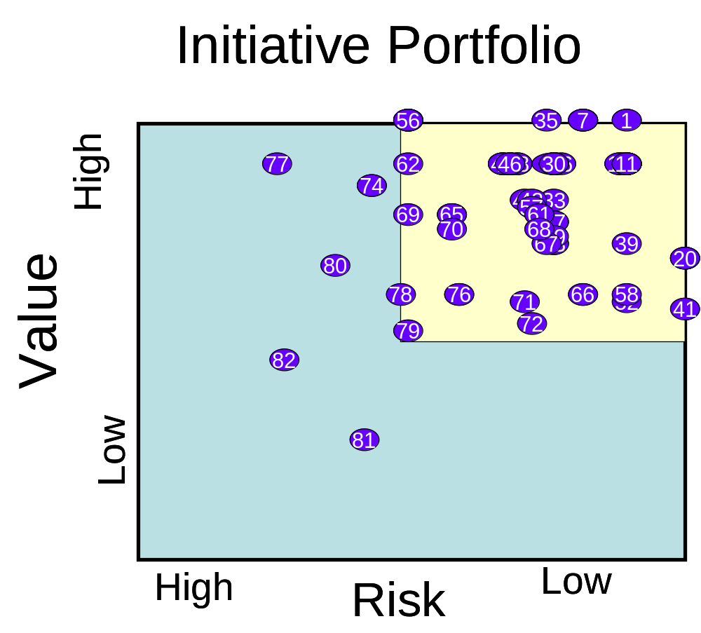

Key Strategies and Prioritization

Initiative Table
The initiatives below are listed in descending order according to their prioritization or “total score”. Initiatives that have the same total score have not been further prioritized within their grouping.
Number | Goal | Objective | Initiative | Impact Score | Value Score | Risk Score
1 | IV | B | Special Event/Fundraising Analysis | 95 | 50 | 45
2 | I | A | Charron Acquisition | 90 | 45 | 45
3 | I | A | Heindel Easement | 90 | 45 | 45
4 | I | A | Lower Acquisition | 90 | 45 | 45
5 | I | C | Lower Mnt. Bethel Open Space Plan | 90 | 45 | 45
6 | I | C | Camp Kresge Master Plan | 90 | 45 | 45
7 | I | C | Trexler Nature Preserve | 90 | 50 | 40
8 | I | C | Lehigh Mnt. Master Site Plan | 90 | 50 | 40
9 | II | B | Monocacy Creek Restoration (Keystone) | 90 | 45 | 45
10 | II | B | Saucon Creek Stream Restoration | 90 | 50 | 40
11 | II | B | Little Lehigh Stabilization at PWS | 90 | 45 | 45
12 | IV | A | Special Events | 90 | 45 | 45
13 | IV | B | Establish a working capital fund | 90 | 45 | 45
14 | IV | D | Establish Pension Program | 90 | 45 | 45
15 | IV | D | Job Description Development | 90 | 45 | 45
16 | IV | D | Employee Annual Review Program | 90 | 45 | 45
17 | IV | D | Employee Incentive/Bonus Program | 90 | 45 | 45
18 | I | A | Hersh Acquisition | 85 | 45 | 40
19 | I | A | Horth Easement | 85 | 45 | 40
20 | I | C | Saucon Creek FGM Assessment | 85 | 35 | 50
21 | I | C | Jordan Creek Greenway Feasibility Study | 85 | 45 | 40
22 | I | C | South Mountain Preserve Implementation Project | 85 | 45 | 40
23 | I | B | Upgrade and repair facilities at PWS | 85 | 45 | 40
24 | II | A | Owl Hole Mine Drainage Assessment | 85 | 45 | 40
25 | II | A | Buck Mnt. #2 Mine Remediation | 85 | 45 | 40
26 | II | B | Swabia Creek Stream Restoration | 85 | 45 | 40
27 | II | C | Lausanne Tunnel Operation & Maintenance | 85 | 45 | 40
28 | II | C | Little Lehigh Creek Water Quality Monitoring | 85 | 35 | 50
29 | II | C | Saucon Creek Water Quality Monitoring | 85 | 35 | 50
30 | III | A | Bike & Boat Program | 85 | 45 | 40
31 | III | D | Bike & Boat Public Days | 85 | 45 | 40
32 | III | D | Agency, Org., and Interest Group Outreach | 85 | 45 | 40
33 | III | D | Lehigh River Sojourn | 85 | 40 | 45
34 | III | C | Create Educational Brochures for Landowners and Municipalities | 85 | 45 | 40
35 | IV | A | Membership Program | 85 | 50 | 35
36 | IV | B | Profitability Ratios | 85 | 45 | 40
37 | IV | E | Increase Number of Working Partners | 85 | 45 | 40
38 | IV | E | Maintain and Enhance Core partners | 85 | 45 | 40
39 | II | A | Buck Mnt. #1 Mine Remediation | 81 | 36 | 45
40 | IV | C | Partner recognition Programs | 81 | 45 | 36
41 | I | C | Saucon Creek Watershed Assessment | 80 | 30 | 50
42 | I | B | Develop Stewardship Plans for Conservancy Properties | 80 | 45 | 35
43 | II | B | Jordan Creek Restoration (Bostick Property) | 80 | 40 | 40
44 | III | B | Provide Educational Programming at PWS and Natural Areas | 80 | 45 | 35
45 | III | A | Navigators | 80 | 40 | 40
46 | III | D | Summer Camp Environmental Programming | 80 | 45 | 35
47 | III | C | Landowner Informational Forums | 80 | 40 | 40
48 | III | C | Lehigh River Municipal Outreach Program | 80 | 45 | 35
49 | IV | C | Marketing Plan | 80 | 45 | 35
50 | IV | C | Communication Plan | 80 | 45 | 35
51 | II | B | South Branch Saucon C. Habitat Improvement Project | 76 | 36 | 40
52 | II | B | Little Lehigh Creek Restoration at LCC Phase II | 76 | 31 | 45
53 | III | A | River Island Camping | 76 | 36 | 40
54 | IV | A | Corporate Fundraising program | 76 | 50 | 26
55 | IV | A | Planned Giving Program | 76 | 50 | 26
56 | IV | A | Major Donor Program | 76 | 50 | 26
57 | IV | C | Create Conservancy brochures | 76 | 41 | 35
58 | II | C | Little Lehigh Army Corps Monitoring | 75 | 30 | 45
59 | III | A | Public Environmental Programming | 75 | 35 | 40
60 | III | D | Invasive Species Training Programs | 75 | 40 | 35
61 | III | D | Lehigh River Corporate and Eco-Challenge | 75 | 40 | 35
62 | I | A | Blue Ridge Acquisition | 71 | 45 | 26
63 | III | D | Family Educational Programming | 71 | 31 | 40
64 | I | B | Improve signage at PWS | 70 | 40 | 30
65 | I | B | Enhance trail system at PWS | 70 | 40 | 30
66 | II | C | Little Lehigh Creek Habitat Assessment | 70 | 30 | 40
67 | III | A | In-school Watershed Presentations | 70 | 35 | 35
68 | II | C | Lehigh River flow maintenance | 67 | 36 | 31
69 | I | A | Crackersport Ponds Acquisition | 66 | 40 | 26
70 | III | B | Reduce Cost Per Student Educated | 65 | 35 | 30
71 | III | D | Gateway Gardens | 65 | 30 | 35
72 | I | A | Mellner Acquisition | 62 | 26 | 36
73 | IV | A | Legacy Lands Funds | 62 | 41 | 21
74 | III | C | Lehigh Valley Greenway Initiative | 61 | 40 | 21
75 | III | E | Hike For Health Project | 60 | 30 | 30
76 | III | E | Hike the Highlands | 60 | 30 | 30
77 | III | B | Establish Proper Holding Area for Educational Animals | 58 | 45 | 13
78 | IV | C | Publish Reports and Books About Lehigh River | 55 | 30 | 25
79 | I | A | Farr Road Acquisition | 53 | 26 | 27
80 | IV | A | Increase Endowment Funds | 49 | 31 | 18
81 | III | E | Walk Around Pennsylvania ASD Pilot Project | 39 | 17 | 22
82 | III | B | Identify Natural Areas Within Walking Distance of Schools | 38 | 21 | 17

Figure 2. Balanced Scorecards
The following Initiatives were prioritized utilizing the process listed in Appendix A.
Goal I. Shelter high-priority natural, agricultural, and recreational areas in the region, and foster responsible stewardship of these assets
Objective | Initiative | Impact Score | Responsible person(s) | Measure | Target | Funding
A. Continue to preserve 1,500 acres per year an average of high-priority land in the region focusing on the Blue Mountain, the Lehigh River corridor, South Mountain, NAI sites, working farms, and area greenways and trails. | Charron Acquisition | 90 | Diane Gehringer | Land Protected | 119 acres 2007 | $678,000  Secured
 | Heindel Easement | 90 | Diane Gehringer | Land Protected | 74.8 acres | $414,500 Secured
 | Lower Acquisition | 90 | Diane Gehringer | Land Protected | 45 acres 2007 | $450,000 50% Secured, 50% Pending
 | Hersh Acquisition | 85 | Diane Gehringer | Land Protected | 10.5 acres 2007 | $65,000 50% secured
 | Horth Easement | 85 | Diane Gehringer | Land Protected | 217 acres 2007 | $1,553,380 Secured
 | Blue Ridge Acquisition | 71 | Diane Gehringer | Land Protected | 3,400 acres 2007-2009 | $8,200,000 Partially secured/pending
 | Crackersport Ponds Acquisition | 66 | Diane Gehringer | Land Protected | 43 acres 2007 | $1,200,000 50% Secured
 | Mellner Acquisition | 62 | Diane Gehringer | Land Protected | 4.4 acres 2007 | $50,000, 50% Secured
 | Farr Road Acquisition | 53 |  | Land Protected | 10 acres 2007 | $900,000, 20% Secured
B. Restore, repair, and upgrade the facilities and properties owned and operated by Wildlands Conservancy. | Upgrade and repair facilities at PWS | 85 | Dan Giannelli | Facility Improved | Ongoing 2007 - 2010 | Un-secured
 | Develop stewardship plans for Conservancy properties | 80 | Debra Lermitte | Plans Completed | Plans Completed 2009 | Un-secured
 | Improve signage at PWS | 70 | Debra Lermitte | Signage designed and installed | Completed 2008 | Un-secured
 | Enhance trail system at PWS | 70 | Tom Gettings | Trails improved | 2009 | Un-secured
C. Identify and implement planning projects to promote the proper stewardship of our land, water, and recreational resources. | Lower Mnt. Bethel Open Space Plan | 90 | Debra Lermitte | Plan Completed | Plan Complete 2007 | Secured
 | Camp Kresge Master Plan | 90 | Debra Lermitte | Plan Completed | Plan Completed 2007 | Secured
 | Trexler Nature Preserve | 90 | Tom Gettings, Debra Lermitte | Implementation Completed | Complete 2010 | $160,000 Secured
 | Lehigh Mnt. Master Site Plan | 90 | Debra Lermitte | Plan Completed | Complete 2009 | Pending
 | Saucon Creek FGM Assessment | 85 | Brian Vadino | Plan Completed | Plan Completed 2007 | Secured
 | Jordan Creek Greenway feasibility study | 85 | Debra Lermitte | Plan Completed | Plan Completed 2008 | Secured  $100,000
 | South Mountain Preserve Implementation Project | 85 | Debra Lermitte | Implemen-tation Completed | Complete 2009 | Pending ($25,000) Match required
 | Saucon Creek Watershed Assessment | 80 | Brian Vadino | Plan Complete | Plan Complete 2009 | 50% Secured

Balanced Scorecards

Goal II. Proactively address water-quality and water-quantity issues to preserve, protect, restore, and enhance the Lehigh River and its tributaries.
Objective | Initiative | Impact Score | Responsible person(s) | Measure | Target | Funding
A. Remediate the abandoned mine drainage (AMD) impacts in the Lehigh River watershed. | Owl Hole Mine Drainage Assessment | 85 | Brian Vadino | Assessment complete | 2008 | $44,222 Secured
 | Buck Mnt. #2 Mine Remediation | 85 | Brian Vadino | Project complete | 2007 | $234,000 Secured
 | Buck Mnt. #1 Mine Remediation | 81 | Brian Vadino | Project complete | 2007 | $5,000 Secured
B. Continue to complete stream bank remediation and protection projects on five critical miles of streams in the Lehigh River watershed. | Monocacy Creek Restoration (Keystone) | 90 | Brian Vadino | 3,000 feet of stream restored | 2007 | $35,000 Secured
 | Saucon Creek Stream Restoration | 90 | Brian Vadino | 1,000 feet of stream | 2008 - 2010 | $300,000 Unsecured
 | Little Lehigh Stabilization at PWS | 90 | Brian Vadino | Restoration complete 250 feet | 2007 | Secured
 | Swabia Creek Stream Restoration | 85 | Brian Vadino | Restoration Complete 2,350 feet | 2006 - 2008 | Unsecured
 | Jordan Creek Restoration (Bostick Property) | 80 | Brian Vadino | 2,000 feet of stream | 2007 | 20,000 50% Secured
 | South Branch Saucon C. Habitat Improvement Project | 76 | Brian Vadino | 1,500 feet of stream restored | 2007 | Unsecured
 | Little Lehigh Creek Restoration at LCC Phase II | 76 | Brian Vadino | 500 feet of stream | 2007 | $10,000 Pending
C. Monitor the quality of local waterways and work to address water-quantity issues in the watershed. | Lausanne Tunnel Operation & Maintenance | 85 | Brian Vadino | Wetlands Maintained | Through 2008 | $10,000 Secured
 | Little Lehigh Creek Water Quality Monitoring | 85 | Brian Vadino | Complete yearly | Yearly next 5 years | $5,000 Secured
 | Saucon Creek Water Quality Monitoring | 85 | Brian Vadino | Complete yearly | Yearly next 5 years | $5,000 Secured
 | Little Lehigh Army Corps Monitoring | 75 | Brian Vadino | Complete yearly | Yearly next 5 years | $2,500 Secured
 | Little Lehigh Creek Habitat Assessment | 70 | Brian Vadino | Assessment complete 2007 | 2007 | $5,000 Secured
 | Lehigh River flow maintenance | 67 | Chris Kocher | Lehigh River improved | 2007 through 2009 | Unsecured

Balanced Scorecards
Goal III. Provide educational and recreational opportunities to the community that will foster appropriate stewardship of the region’s natural treasures.
Objective | Initiative | Impact Score | Responsible person(s) | Measure | Target | Funding
A. Provide experiential education and awareness opportunities for school - aged students. | Bike & Boat Program | 85 | Maureen Ruhe | Number of students and Number of programs | 3,000 students per year and 60 programs | Provided by participants
 | Navigators | 80 | Maureen Ruhe | Number of programs | 12 programs per year | Provided by participants
 | River Island Camping | 76 | Maureen Ruhe | Number of programs | 12 programs per year | Provided by participants
 | Public Environmental Programming | 75 | Maureen Ruhe | Number of programs | 12 programs per year | Provided by participants
 | In-school Watershed presentations | 70 | Maureen Ruhe | Number of programs | 12 programs per year | Provided by participants
B. Use Pool Wildlife Sanctuary and other natural areas to provide educational opportunities which conform to the state’s educational mandates for school-age children. | Provide Educational programming at PWS and other natural areas | 80 | Maureen Ruhe | Number of Children engaged | 18,000 | Provided by participants
 | Reduce cost per student educated | 65 | Maureen Ruhe | Cost per student | $8.00 per student by 2007 | Program
 | Establish proper holding area for educational animals | 58 | Maureen Ruhe | Facility completed | 2007 | $20,000 50% secured, need matching dollars
 | Identification of Natural Areas within walking distance of schools | 38 | Maureen Ruhe | Natural Areas identified | 2007 | Program
C. Offer educational leadership by providing programs and services for local governments and landowners. | Create educational brochures for landowners and municipalities | 85 | Debra Lermitte | Number of brochures produced | 2007 - 2009 | Secured
 | Landowner informational forums | 80 | Diane Matthews Gehringer | Number of attendees | 2 yearly | Unsecured
 | Lehigh River Municipal Outreach Program | 80 | Debra Lermitte | Number of entities reached | Completion 2007 | Secured
 | Lehigh Valley Greenway Initiative | 61 | Chris Kocher | Number of partners & number of projects completed | 2007 - 2010 | Secured
D. Provide experiential education and awareness opportunities for the general public. | Bike & Boat Public Days | 85 | Maureen Ruhe | Completion of events | 10 per year | Provided by participants
 | Agency, Organization, and Interest Group Outreach | 85 | Maureen Ruhe | Completion of programs | 15 per year | Provided by participants
 | Lehigh River Sojourn | 85 | Consultant/ volunteers | Completion of event | 1 per year | Sponsorship and participants
 | Summer Camp Environmental Programming | 80 | Maureen Ruhe | Number of programs | 45 weeklong programs | Provided by participants
 | Invasive Species Training Programs | 75 | Debra Lermitte | Completion of Training | 3 training sessions | Secured
 | Lehigh River Corporate and Eco Challenge | 75 | Maureen Ruhe | Completion of programs | 5 per year | Provided by participants
 | Family Educational Programming | 71 | Maureen Ruhe | Completion of programs | 30 programs per year | Provided by participants
 | Gateway Gardens | 65 | Debra Lermitte | Completion of Gardens | Completion of three Gardens | Secured
E. Provide innovative educational programming to encourage knowledge and appreciation of nature and to foster healthy, life-affirming activities for residents and visitors. | Hike For Health Project | 60 | Tom Gettings | Completion of Program | Completion by 2008 | Pending
 | Hike the Highlands | 60 | Tom Gettings | Program Completion | 2008 | Pending
 | Walk Around Pennsylvania Allentown School District Pilot Project | 39 | Tom Gettings | Completion of Pilot project | Completion by 2007 | Pending

Balanced Scorecards

Goal IV. Ensure a sustainable organization with a sound financial operation.
Objective | Initiative | Impact Score | Responsible person(s) | Measure | Target | Funding
A. Increase and diversify organizational funding. | Special events | 90 | Sharon Ettinger | Successful events | All profitable by 2008 | Participants
A. Increase and diversify organizational funding. | Membership Program | 85 | Sharon Ettinger | Total Members | 4,000 members in 5 years | Advancement
A. Increase and diversify organizational funding. | Corporate Fundraising program | 76 | Sharon Ettinger | Total dollars raised | $20,000 per year | Advancement
A. Increase and diversify organizational funding. | Planned Giving Program | 76 | Sharon Ettinger | Program established | Establishment of a program by 2007 | Advancement
A. Increase and diversify organizational funding. | Major Donor Program | 76 | Chris Kocher | Program established | Establish program by 2007 | Advancement
A. Increase and diversify organizational funding. | Legacy Lands Funds | 62 | Chris Kocher, Tom Gettings | Total Funds secured | Raise $500,000 by 2011
A. Increase and diversify organizational funding. | Increase Endowment funds | 49 | Sharon Ettinger | Total funds secured | ongoing | Advancement
B. Ensure a sound financial operation to provide flexibility and growth. | Special Event/Fundraising Analysis | 95 | Dan Giannelli | Return on Investment | 1.0 or better on all events | Operations
 | Establish a working capital fund | 90 | Dan Giannelli | Fund established | Established 2008 | Operations
 | Profitability Rations | 85 | Dan Giannelli | Profit Margin, Rtn on Assest/Rtn on Equity | 3% by 2008, Establish benchmarks | Operations
C. Improve the marketing of the organization’s programs and activities. | Partner recognition Programs | 81 | Chris Kocher | Program continuation | Yearly | Operations
 | Marketing Plan | 80 | Chris Kocher | Complete Plan | 2008 | Unsecured
 | Communication Plan | 80 | Chris Kocher | Complete Plan | 2007 | Unsecured
 | Create Conservancy brochures | 76 | Sharon Ettinger | Brochure completion | Ongoing | Unsecured
 | Publish reports and books about Lehigh River | 55 | Tom Gettings, Brian Vadino | Completion of reports and books | 2009 - 2011 | Partially secured
D. Develop and attract career professionals with a commitment to our principals and goals. | Establish Pension Program | 90 | Dan Giannelli | Program established | 2007 | Operations
 | Job Description development | 90 | Chris Kocher | Job descriptions for staff complete | 2007 | Operations
 | Employee Annual Review Program | 90 | Chris Kocher | Program established | 2007 | Operations
 | Employee Incentive/Bonus Program | 90 | Chris Kocher | Program established | 2007 | Surplus
E. Maintain, enhance, and diversify partnerships. | Increase number of working partners | 85 | Program managers | Number of active partners | Increase working partners by 20% | Operations
E. Maintain, enhance, and diversify partnerships. | Maintain and enhance Core partners | 85 | Chris Kocher | Maintain and enhance relationships with 10 core partners | Yearly | Secured
Timeline
The final step of the Strategic Action Plan was the development of an implementation timeline. Figure 3 provides the schedule for implementation for each of the initiatives of this Strategic Plan.

The scheduling and prioritization of initiatives in this plan were based upon conditions and information at the time that this plan was prepared. Priorities may change under the following conditions: Trigger events such as the passage of legislation or funding opportunities when a source is identified and the timeline is known.

Figure 3. Wildlands Conservation Strategy Schedule
 | Year
 | 2006 |  |  | 2007 |  |  |  | 2008 |  |  |  | 2009 |  |  |  | 2010
Initiatives | A | J | O | J | A | J | O | J | A | J | O | J | A | J | O | J | A | J | O
Goal I. Shelter high-priority natural, agricultural, and recreational areas in the region, and foster responsible stewardship of these asset.

A. Continue to preserve an average of 1,500 acres of high-priority land in the region focusing on Blue Mountain, the Lehigh River corridor, South Mountain, NAI site, working farms, and area greenways and trails.
Charron acquisition
Hersh acquisition
Horth easement
Farr Road acquisition
Blue Ridge acquisition
Mellner acquisition
Heindel easement
Crackersport Ponds acquisition
Lower acquisition
C. Identify and implement planning projects to promote the proper stewardship of our land, water, and recreational resources.
Lower Mt. Bethel Open Space Plan
Camp Kresge Master Plan
Saucon Creek FGM Assessment
Saucon Creek Watershed Assessment
South Mountain Preserve Implementation Project
Trexler Nature Preserve
Lehigh Mt. Master Site Plan
Jordan Creek Greenway Feasibility Study
 | 2006 |  |  | 2007 |  |  |  | 2008 |  |  |  | 2009 |  |  |  | 2010
 | A | J | O | J | A | J | O | J | A | J | O | J | A | J | O | J | A | J | O
B. Restore, repair, and upgrade the facilities and properties owned and operated by Wildlands Conservancy.
Improve signage at PWS
Upgrade and repair facilities at PWS
Develop stewardship plans for Conservancy properties
Enhance trail system at PWS
Goal II. Proactively address water-quality and water-quantity issues to preserve, protect, restore, and enhance the Lehigh River and its tributaries.

A. Remediate the abandoned mine drainage (AMD) impacts in the Lehigh River watershed.
Buck Mt. #2 mine remediation
Buck Mt. #1 mine remediation
Owl Hole Mine Drainage Assessment
B. Continue to complete streambank remediation and protection projects on five critical miles of streams in the Lehigh River watershed.
Monocacy Creek Restoration (Keystone)
Jordan Creek Restoration (Bostick Property)
Little Lehigh Creek Restoration at LCC Phase II
Little Lehigh Stabilization at PWS
Swabia Creek Stream Restoration
Saucon Creek Stream Restoration
 | 2006 |  |  | 2007 |  |  |  | 2008 |  |  |  | 2009 |  |  |  | 2010
 | A | J | O | J | A | J | O | J | A | J | O | J | A | J | O | J | A | J | O
C. Monitor the quality of local waterways and work to address water-quantity issues in the watershed.
Little Lehigh Creek Water Quality Monitoring
Little Lehigh Creek Habitat Assessment
Saucon Creek Water Quality Monitoring
Lehigh River flow maintenance
Little Lehigh Army Corps Monitoring
Lausanne Tunnel Operation & Maintenance
Goal III. Provide educational and recreational opportunities to the community that will foster appropriate stewardship of the region’s natural treasures.
A. Use Pool Wildlife Sanctuary and other natural areas to provide educational opportunities that conform to the state’s educational mandates for school-age children.
Provide Educational programming at PWS and other natural areas
Reduce cost per student educated
Identification of Natural Areas within walking distance of schools
Establish proper holding area for educational animals
B. Provide experiential education and awareness opportunities for school-age students.
Bike & Boat Program
In-school Watershed presentations
Public Environmental Programming
 | 2006 |  |  | 2007 |  |  |  | 2008 |  |  |  | 2009 |  |  |  | 2010
 | A | J | O | J | A | J | O | J | A | J | O | J | A | J | O | J | A | J | O
River Island Camping
Navigators
C. Provide experiential education and awareness opportunities for the general public.
Lehigh River Corporate and Eco-Challenge
Agency, Organization, and Interest Group Outreach
Lehigh River Sojourn
Summer Public Environmental Programming
Bike & Boat Public Days
Gateway Gardens
Family Educational Programming
Invasive Species Training Programs
D. Offer educational leadership by providing programs and services for local governments and landowners.
Lehigh River Municipal Outreach Program
Landowner informational forums
Lehigh Valley Greenway Initiative
Create educational brochures for landowners and municipalities
E. Provide innovative educational programming to gain knowledge and appreciation of nature and to foster healthy, life-affirming activities for residents and visitors.
Hike For Health Project
Walk Around Pennsylvania Allentown School District Pilot Project
Hike the Highlands
 | 2006 |  |  | 2007 |  |  |  | 2008 |  |  |  | 2009 |  |  |  | 2010
 | A | J | O | J | A | J | O | J | A | J | O | J | A | J | O | J | A | J | O
Goal IV. Ensure a sustainable organization with a sound financial operation.

A. Increase and diversify organizational funding.
Membership Program
Corporate Fundraising program
Planned Giving Program
Special events
Legacy Lands Funds
Increase Endowment funds
Major Donor Program
B. Ensure a sound financial operation to provide flexibility and growth.
Special Event/Fundraising Analysis
Establish working capital fund
Profitability Rations
C. Maintain, enhance, and diversify partnerships.
Increase number of working partners
Maintain and enhance Core partners
D. Develop and attract career professionals with a commitment to our principals and goals.
Establish Pension Program
Job Description development
Employee Annual Review Program
Employee Incentive/Bonus Program
 | 2006 |  |  | 2007 |  |  |  | 2008 |  |  |  | 2009 |  |  |  | 2010
 | A | J | O | J | A | J | O | J | A | J | O | J | A | J | O | J | A | J | O
E. Improve the marketing of the organization’s programs and activities.
Communication Plan
Partner recognition /Award Programs
Create Conservancy brochures
Publish reports and books about Lehigh River
Marketing Plan

Certain
Approximate

Funding Plan
The funding plan is the identification of financial institutions where certain types and amounts of funding can be applied for specific projects. While this seems quite simple, the process can be very complicated. Knowing what each group is likely to do is the key. Having a relationship with them so they know who you are and have some confidence in the group’s ability to perform well and use the money wisely is also very important. Below is a list of the funding institutions, application dates, responsible person to procure the funds, the likely amount the funding entities will allow and the date the money is available for the project.
Wildlands Conservancy Funding Plan
Goal | Funding Institution | Application Date | Responsible Person | Amount | Funding Date
I | PA DCNR | Spring and Fall | Debra Lermitte Chris Kocher | $500,000 +/year | July 2007
Multiple | William Penn Foundation | Bi-Annual | Chris Kocher | $200,000/year | September 2007
II | PA DEP | Spring | Brian Vadino | $250,000 +/year | September
Multiple | Harry C. Trexler Trust | December | Chris Kocher | $50,000/year | April
I | County of Lehigh | N/A | Debra Lermitte | $40,000/year | N/A
III | Air Products Foundation | April | Sharon Ettinger | $8,500/year | December
II | Reidler Foundation | April | Chris Kocher | $10,000/year | July
III | Donley Foundation | March | Maureen Ruhe | $5,000/year | July
III | Rider-Pool Foundation | April | Chris Kocher | $8,000/year | August
I | Nat. Fish & Wildlife Fnd. | August | Debra Lermitte | Project Dependant | December
III | Holt Family Foundation | April | Maureen Ruhe | $2,500/year | July
III | Payne Foundation | March | Maureen Ruhe | $2,500/year | July
Multiple | Lehigh Valley Comm. Fnd. | June | Sharon Ettinger | Project Dependant | December
III – IV | R.K. Laros Foundation | February | Sharon Ettinger | Project Dependant | June
III | Charles Hoch Foundation | March | Maureen Ruhe | $1,500/year | June
III | Just Born, Inc. | June | Maureen Ruhe | $3,000/year | October
III | U.S. Dept. of Education | April | Maureen Ruhe | Project Dependant | July
III | Mack Truck Comm. Grants | August | Chris Kocher | $25,000 | November
III | Baker Foundation | March | Maureen Ruhe | $5,000/year | October
III | Bastian Foundation | September | Maureen Ruhe | Project Dependant | July
III | Pa. Dept. of Education | Multiple | Maureen Ruhe | $10,000 | Multiple
II | Cora L. Brooks Foundation | April/September | Chris Kocher | $10,000/two years | Multiple
III | First Union/Wachovia | February | Maureen Ruhe | $1,500 | July
III | Lebovitz Fund | September | Maureen Ruhe | $1,000/year | December
III | Binney & Smith | December | Maureen Ruhe | $3,000/year | March
II | WREN Grant Program | April | Brian Vadino | $5,000 | July
IV | POWR Grants | March | Sharon Ettinger | $4,000/year | June
Multiple | Norcross Foundation | April | Chris Kocher | $10,000 | July
III | Ruth B. Seruga | July | Sharon Ettinger | Project dependant | December
General | Graymer Foundation |  | Sharon Ettinger | $1,000
General | Keystone Naz. Charitable | August | Sharon Ettinger | $4,000/year | December
III | Martin Foundation | March | Brian Vadino | $1,500/year
III | Priscilla Payne Hurd Fnd. | April | Tom Gettings | Project dependant | July

Core Partners
Wildlands Conservancy has completed many significant projects over its 34-year history. Many of these projects would not have been possible without the support of many partnering organizations. The organization has two levels of partners, core partners and working partners. Core partners are defined as partners that are essential to the organization’s mission. Without the ongoing support of these core partners the organization would not be able to meet its goals and complete its mission. Working partners are defined as partners who are critical to the success of individual projects and enable the organization to complete its programmatic objectives. The organization has identified several core partners and will work to maintain and enhance these critical relationships to further enhance the organization and enable it to fulfill its mission and vision.
Pennsylvania Department of Conservation and Natural Resources
The Pennsylvania Department of Conservation and Natural Resources provides significant funding for the acquisition of open space, rivers conservation planning, greenway and trail development, and park development. The Pa. DCNR has been a major source of funds for the organization’s activities since the early 1990s. The Pa. DCNR is also spear-heading an effort called the Lehigh Valley Greenway Initiative, which is focusing additional DCNR support on the Lehigh Valley. The Conservancy needs to maintain and enhance it’s relationship with DCNR to ensure that continued funding is available for the Conservancy’s projects. Ongoing communication is necessary with DCNR’s regional manager, Dennis DeMara, the Lehigh Valley Greenway Initiative Manager, Diane Kripas, and all project coordinators in Harrisburg. Additional effort is needed to continue it’s relationship with Secretary Michael Diberardinis.
Pennsylvania Department of Environmental Protection
The Pennsylvania Department of Environmental Protection provides significant funding for the Conservancy’s watershed restoration and planning projects. Pa. DEP has been a major source of funds for the organization’s activities since the early 1990s. The Conservancy needs to maintain and enhance our relationship with DEP to ensure that continued funding is available for the Conservancy’s projects. Ongoing communication is necessary with the watershed manager, Andy Schweitzer, the regional director, Mike Bedrin, and all grant project managers from the northeast regional office. Additional effort is needed to continue the relationship with Secretary Kathleen McGinty.
County of Lehigh
The County of Lehigh has provided significant funding for the Conservancy’s land protection program, and the Conservancy has several contracts with the County to perform services. Most notable is the contract to implement the Trexler Nature Preserve Master Site Plan. The current administration relies on the Conservancy for land-use issues and input on its open space acquisition program. The Conservancy needs to maintain and enhance it’s relationship with Lehigh County to ensure that continued funding is available for the Conservancy’s projects. Ongoing communication is necessary with the director of general services Jan Creedon and the County Executive Don Cunningham.

The William Penn Foundation
The William Penn Foundation is the organization’s largest source of private foundation funds. The William Penn Foundation has funded a variety of Conservancy projects over the last several decades. The foundation’s main focus is on the five-county region around Philadelphia, but it has contributed annually to Conservancy projects in the Lehigh Valley. The Conservancy needs to maintain ongoing communication with Andrew Johnson, our project officer, and continue to provide projects in which the foundation sees a value worth funding.
Harry C. Trexler Trust
The Harry C. Trexler Trust has provided significant funding for Wildlands Conservancy since the founding of the organization. The Trust’s giving is restricted to Lehigh County and has focused primarily on capital projects and education. The Trust’s has also supported the Conservancy’s efforts along the Jordan Creek corridor and at the Trexler Nature Preserve. Ongoing communication is necessary with the Foundation’s executive director, Janet Roth, and with each of the five trustees.

2007 Annual Operating Budget
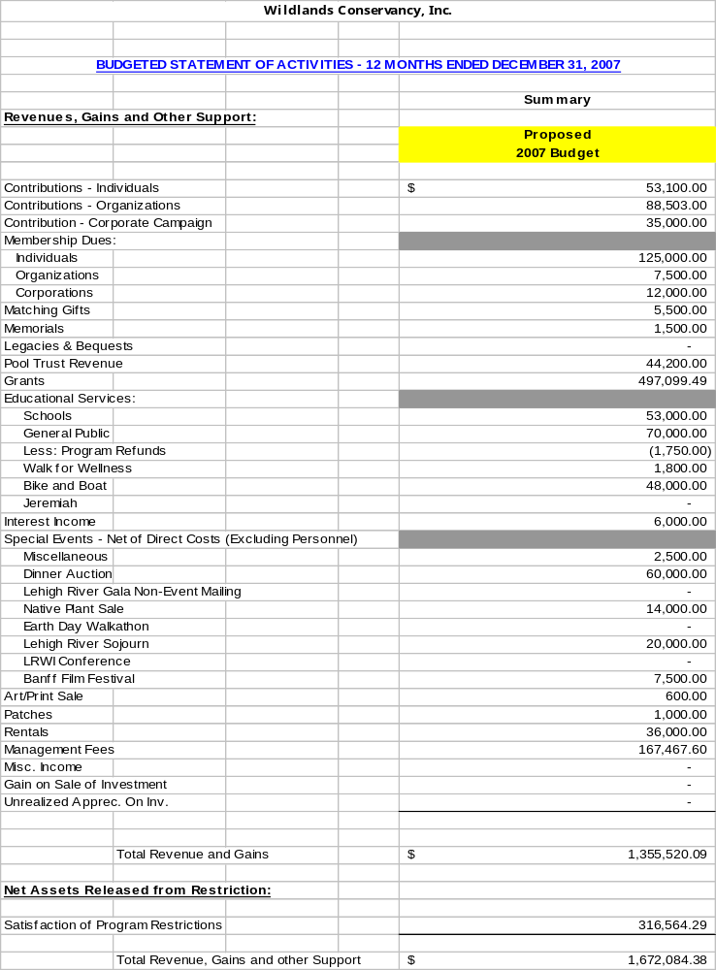

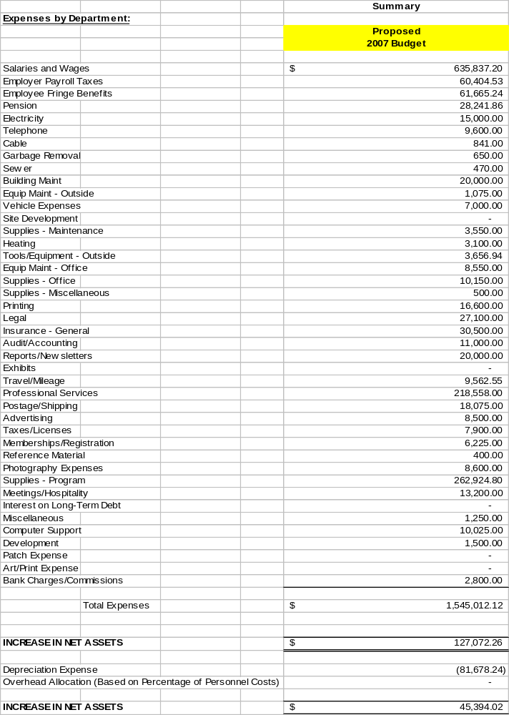
APPENDIX A
Strategic Planning Process and Portfolio Analysis

Assessment
The process began with an Assessment. This assessment looks eleven strategic criteria and organizational capacity factors. The process was used to assess the current status in accomplishing each objective as well as investigate the desired level of performance on each. This assessment provides a comprehensive snapshot of current organizational and strategic strengths and weaknesses and an indication of areas where further progress is needed to advance toward a sustainable organizational model. Using the results of this assessment, priorities were established for the Conservancy.

A Mission-Driven Plan
Next the process of defining the vision and goals for the Partnership established an overall framework for collaboration and inspired a shared purpose. To create an actionable conservation strategy, the key conservation initiatives were identified to be implemented collectively by Wildlands Conservancy. The initiatives identification process examined a broad spectrum of possible conservation actions, ranging from the development of forest preservation plans to compatible economic development gateway selection and design. The process explicitly considered whether the initiatives were well matched to the mission of the Conservancy; the initiatives portfolio was also assessed in its entirety to determine whether each of the organization’s goals was adequately addressed in the list of initiatives. The outcome of this process was a set of eighty-two strategically selected initiatives which supported the goals and vision of Wildlands Conservancy.

Prioritization of Actions
To develop a workable, staged plan of action, a prioritization process followed next. The eighty-two initiatives were evaluated using a process which considered the pros and cons of each so that a relative assessment of both value and risk could be made. Every initiative was scored on ten criteria as described below.

The Value Analysis step examined the importance of the following five elements of value:
- Urgency of need
- Importance
- Profitability
- Desirability among key stakeholders
- Extent to which the initiative affects the overall Conservancy effort

The Risk Analysis scored each initiative on five elements of risk:
- Concept track record
- Program design
- Capability of available people to execute the initiative
- Level of training needed
- Uncertainty/politics

Each Value or Risk Measure was scored on a scale from 1 to 10. The scores for each Measure were summed within groups, yielding two scores: a Value Score as well as a Risk Score. From these a summative overall Impact Score was developed, totaling the Value and Risk scores. As each of the Value and Risk Scores could range from 5 to 50, the Impact Scores for each Initiative could range from 10 to 100. It is important to recognize that both the Value and Risk scales were designed such that a high score reflects a positive assessment of the initiative. A high Risk Analysis score represents an assessment that the initiative carries a manageable level of risk. It is not the case that a high risk score reflects a concern that there is a high level of risk associated with the initiative.

The Prioritization process gave more detailed consideration to the paired Value and Risk attributes of each initiative and the strategic implications for the Partnership’s Action Plan. As an aid to the planning process, each initiative was represented on a plot of risk versus value.

Figure 1 illustrates the results of the pair wise examination of Risk and Value Scores for each of the Initiatives. Those initiatives that fall in the upper right quadrant are strong candidates and are designated as Priorities.

A high Impact Score reflected an initiative which was assessed favorably on both value and risk attributes. The higher the Impact score, the higher the preliminary prioritization of the initiative.

Balanced Scorecard
Next a balanced scorecard was created, identifying how performance would be measured on each of the initiatives. The balanced scorecard method creates a set of measures intended to provide a fast and comprehensive view of the initiatives and the strategic plan. The notion of a “balanced score card” reflects its emphasis on ensuring each key strategy element is being adequately measured to ensure high performance. Figure 2 presents the balanced scorecard for the initiatives. Figure 2 shows how each goal and objectives are supported by one or more initiatives. Each initiative was linked to one or more of the Conservancy’s goals, tasks for implementation were identified, timing issues considered, and other implementation and performance monitoring issues considered. Each initiative has an impact score, responsible person, a measurable outcome and a short term target.

APPENDIX B
Initiatives

