Introduction
Relatively few public opinion surveys explore the environmental views of Pennsylvanians. Those that do show that most Pennsylvanians care about protecting the Commonwealth’s water, land, wildlife, and air. Majorities believe the government should limit pollution, protect public parks and forests, and lead the shift from fossil fuels to renewable energy sources.
This guide highlights the findings of recent polls pertaining to regulation, the function of government agencies, and climate change and energy issues. A companion guide, How Pennsylvanians View Government Funding of Conservation: An Overview of Polling and Voting Results, examines how the public views government investments in conservation.

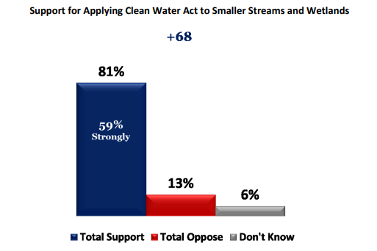
Angler and Hunter Views on Clean Water Regulations
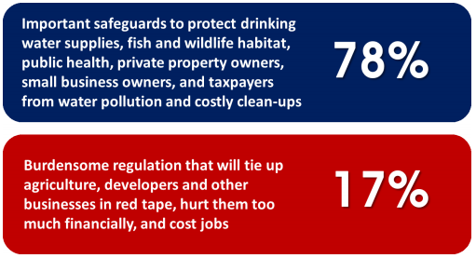
Anglers and hunters, who are more likely to have conservative political views and/or identify as Republicans, express support for conservation. A 2015 poll regarding the federal Clean Water Act found that 81% of registered Pennsylvania voters who identify as hunters and/or anglers support applying the Act to smaller headwater streams and wetlands, with nearly six in 10 (59%) indicating strong support. A large majority of Republicans (73%), independents (83%), and Democrats (95%) are all in favor.
This support makes sense considering that 85% of Pennsylvania voters who hunt or fish believe that protecting water quality and habitat is compatible with a strong economy, and that 78% view this application of the Clean Water Act as an “important safeguard” rather than a “burdensome regulation.”

Wildlife Conservation
A 2014 poll found that Pennsylvanians view habitat loss and urban sprawl as the biggest threats to nongame wildlife in the state. A vast majority of respondents (92%) also believe that conserving threatened and endangered species is an important function of the Pennsylvania Game Commission and Fish and Boat Commission; 75% believe this is a “very” important function.

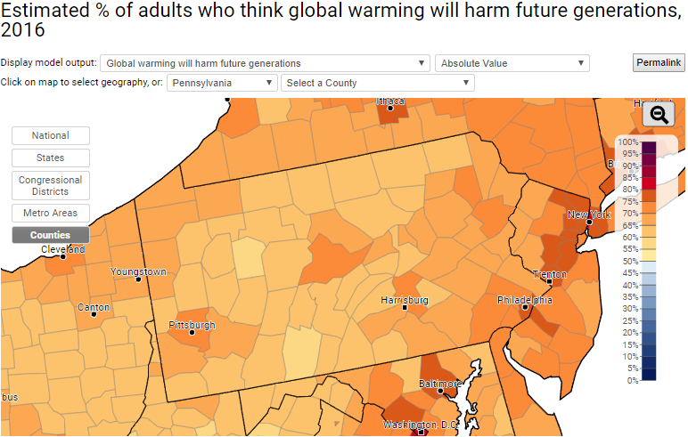
Global Warming and Pollution
Data from the Yale Program on Climate Change Communication shows that most Pennsylvania voters are concerned about global warming and its impact: 69% believe global warming is happening, and more than half (58%) report being “worried” about it. Philadelphia County has the highest percentage of worried voters (72%), while Bedford and Jefferson counties have the lowest (46%). Nearly seven in 10 voters statewide believe that global warming will harm future generations (69%) as well as plants and animals (68%).
Strong majorities of Pennsylvania voters think the government should combat global warming by reducing the pollution that causes it. Eighty-two percent support funding research into renewable energy sources, and 65% support laws requiring utilities to produce 20% electricity from renewable sources. Furthermore, 76% support regulating carbon dioxide as a pollutant, and 69% support strict carbon dioxide limits on existing coal-fired power plants.
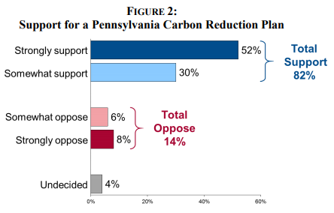
A 2015 poll found that 82% of Pennsylvania voters support the development of a state plan to reduce carbon pollution and increase clean energy and energy efficiency, including 30% who express “strong” support. Democrats (89%), Republicans (77%), and independents (73%) all agree on this state-level approach. If the governor implemented such a plan, only 7% would view them less favorably.

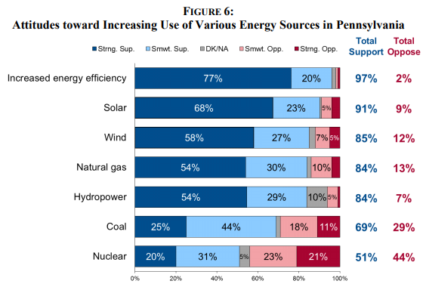
Renewable Energy
The same 2015 poll found that more than six in 10 Pennsylvania voters (61%) say that increased renewable energy will create jobs, compared to only 16% who think it will cost jobs. More voters (47%) believe clean energy will reduce energy costs than increase costs (33%). Nearly all voters (97%) support increases in energy efficiency, including 77% expressing “strong” support. Voters also overwhelmingly support solar (91%), wind (85%), and hydropower (84%). Relatively fewer voters (69%) support coal as an energy source, and relatively more (29%) oppose it.

Fracking in State Parks and Forests
Pennsylvania offers many opportunities for its residents to experience the outdoors. There are 121 state parks, comprised of more than 200,000 acres, as well as two million acres of state forest. Among Pennsylvanians, there is solid support for protecting these lands. A 2014 poll found that 57% of Pennsylvania voters oppose natural gas extraction under state parks and forests, compared to 36% in favor. Responses broke along political lines to a greater degree than other conservation-related polls, with 71% of Democrats, 58% of independents, and 38% of Republicans in opposition.

Resources at ConservationTools.org
To find related resources, see the right column of the online edition at http://conservationtools.org/guides/153
***

Comments
Help improve the next edition of this guide. Email your suggestions to the Pennsylvania Land Trust Association at aloza@conserveland.org. Thank you.

Acknowledgements
Nate Lotze authored this guide.
The Pennsylvania Land Trust Association published this guide with support from the Community Conservation Partnerships Program, Environmental Stewardship Fund, under the administration of the Pennsylvania Department of Conservation and Natural Resources, Bureau of Recreation and Conservation.

© 2017 Pennsylvania Land Trust Association
Text may be excerpted and reproduced with acknowledgement of ConservationTools.org and the Pennsylvania Land Trust Association

Pennsylvania Survey of Hunters and Anglers Regarding Clean Water Act. Conducted by Public Opinion Strategies and Greenberg, Quinlan, and Rosner for the National Wildlife Federation (2015). Telephone (50%) and internet (50%) surveys of 286 registered voters in Pennsylvania who identify as hunters and/or anglers, from June 23-July 4, 2015.
Pennsylvania Residents’ Opinions on and Attitudes Toward Nongame Wildlife. Conducted by Responsive Management for the Pennsylvania Game Commission, in cooperation with Pennsylvania Fish and Boat Commission (2014). Telephone survey of 3,660 Pennsylvania residents in 2014.
Yale Climate Opinion Maps—U.S. 2016. Model estimates based on data from Climate Change in the American Mind surveys of registered voters conducted by the Yale Program on Climate Change Communication and George Mason University Center for Climate Change Communication (2008-2016). http://climatecommunication.yale.edu/visualizations-data/ycom-us-2016
Climate Action and Clean Energy in Pennsylvania Poll. Conducted by Public Opinion Strategies (Republican) and FM3 (Democratic) for the National Resources Defense Council (2015). Telephone survey of 400 registered voters in Pennsylvania from December 17-18, 2014.
Pennsylvania Voters’ Opinion on Fracking in Parks. Conducted by Quinnipiac University (2014). Telephone survey of 1,308 registered voters in Pennsylvania from May 29-June 2, 2014.

