Introduction
Polls show strong support for conservation across the Commonwealth. Overwhelming majorities of Pennsylvanians—regardless of political affiliation or region—value open space and outdoor recreation and believe that investments in conservation are crucial. Pennsylvanians have affirmed these poll results at the ballot box, approving more than a billion dollars for conservation funding on local, county, and statewide ballots in recent decades.

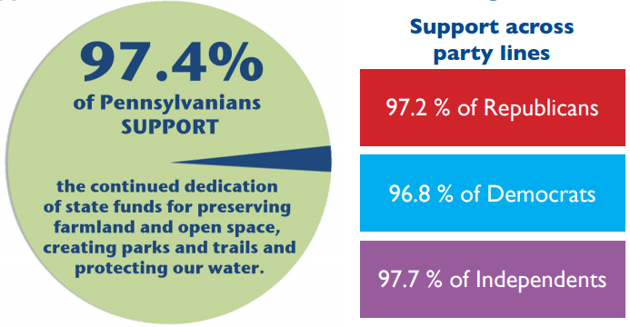
Statewide Polls

Support for Continuing State Funding
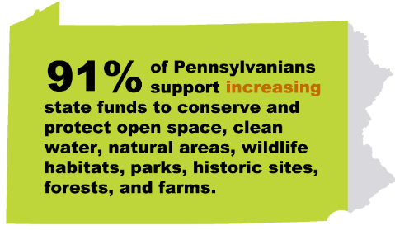
Pennsylvanians overwhelmingly support the use of state funds for conservation. In a 2014 poll, 97% said they support the continued dedication of state funds for land and water conservation, protection of historic sites, and farmland preservation.

Support for Paying More
In a 2015 poll, 90% of Pennsylvanians said they support increasing state funding for these same purposes.
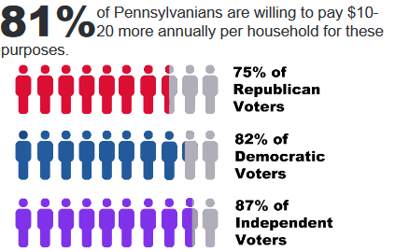
According to the poll, a solid 80% are in favor of increased conservation funding even if it would cost the average household $10-20 more per year. Independents (86%) are the most willing to pay extra, followed by Democrats (82%) and Republicans (75%). A majority in every region are supportive, from a low of 69% in the northwest part of the state to a high of 90% in the northcentral region.

Support for Particular Funding Mechanisms
The same 2015 poll found that more than four-fifths (83%) support setting aside the money from oil and gas leases on state forest land in a permanent conservation trust fund to improve state parks, forests, and other natural areas.
In a 2016 poll, 81% of respondents said they support placing a fee on commercial water use in Pennsylvania to fund the protection and restoration of rivers and streams, including 40% who “strongly” support it. Seventy-one percent of Republicans (including 30% “strongly”) and 89% of Democrats (including 58% “strongly”) support a commercial water use fee.

Ballot Results
Pennsylvanians have consistently demonstrated their support for conservation by approving local, county, and statewide ballot measures to allocate public money to open space protection through taxes and bonds. Since 1988, voters have said yes to 79% of these ballot measures (128 of 162), approving more than $1.4 billion in conservation funding. Many of the measures passed by large margins. (Pennsylvania ranks fourth in the nation in total number of measures passed, and 12th in total amount of conservation funds approved.)
For more information on conservation ballot measures, see The Trust for Public Land’s LandVote database.

Local Polls
The statewide polls found strong support for conservation in every region of Pennsylvania but did not examine any one county in depth. It appears that only one poll in recent years has done this.
A 2016 poll of registered voters in Lancaster County examined opinions regarding farmland preservation. The poll found that:
- Most (83%) voters were either “very” or “somewhat” concerned about loss of farmland.
- Support for farmland preservation transcends political party, even among the most active voters: Republicans (72%) and Democrats (84%) support increased efforts to preserve farmland, as do 71% of Republican households with a history of voting in GOP primary elections.
- Seventy-seven percent of voters are in favor of continued use of public funds for farmland preservation, including 34% “strongly” in favor.
- A majority (61%) said they are willing to pay more to ensure farmland preservation.

Resources at ConservationTools.org
To find related resources, see the right column of the on-line edition at http://conservationtools.org/guides/152

***

Comments
Help improve the next edition of this guide. Email your suggestions to the Pennsylvania Land Trust Association at aloza@conserveland.org. Thank you.

Acknowledgements
Nate Lotze authored this guide. Andrew M. Loza edited it.
The Pennsylvania Land Trust Association published this guide with support from the Community Conservation Partnerships Program, Environmental Stewardship Fund, under the administration of the Pennsylvania Department of Conservation and Natural Resources, Bureau of Recreation and Conservation.

© 2017 Pennsylvania Land Trust Association
Text may be excerpted and reproduced with acknowledgement of ConservationTools.org and the Pennsylvania Land Trust Association

Pennsylvania Statewide Public Opinion Survey. Conducted by the Center for Survey Research at Penn State Harrisburg for The Nature Conservancy and The Trust for Public Land (2014). Telephone survey of 606 adult Pennsylvanians in June, 2014.
Pennsylvania Statewide Public Opinion Survey. Conducted by the Center for Survey Research at Penn State Harrisburg for The Nature Conservancy and The Trust for Public Land (2015). Telephone survey of 601 adult Pennsylvanians from March 4-April 15, 2015.
Fall 2016 Penn State Conservation Poll. Conducted by the Center for Survey Research at Penn State Harrisburg for the Growing Greener Coalition (2016). Telephone survey of 605 adult Pennsylvanians from September 8-October 29, 2016.
LandVote Database. The Trust for Public Land. www.landvote.org
Lancaster County Farmland Preservation Poll. Conducted by Susquehanna Polling and Research for Lancaster Farmland Trust (2016). Telephone survey of 402 registered voters in Lancaster County from December 6-10, 2015.

