Introduction 1
Conservation is Important 1
Red, Blue, or Purple, States Support Green 4
State and Local Ballot Results Confirm Survey Findings 5
Views of Hunters and Anglers 6
National Parks 7
Wildlife Conservation 8
Resources at ConservationTools.org 8

Introduction
Polls show that support for land conservation and public space for outdoor recreation is strong across the United States. A majority of voters believe that investing in conservation is important, regardless of their political affiliation or the state of the economy. Surveys show that voters understand the vital role conservation plays in their communities. Election results reinforce these findings: in recent decades, voters nationwide have approved billions of dollars in conservation funding.
Since Pew Research Center began polling on environmental issues in the early 1990s, public support for environmental protection in general has remained high. According to 2016 data, 74% of Americans believe the country should “do whatever it takes to protect the environment” compared to 23% who said the country has “gone too far” in environmental protection efforts.

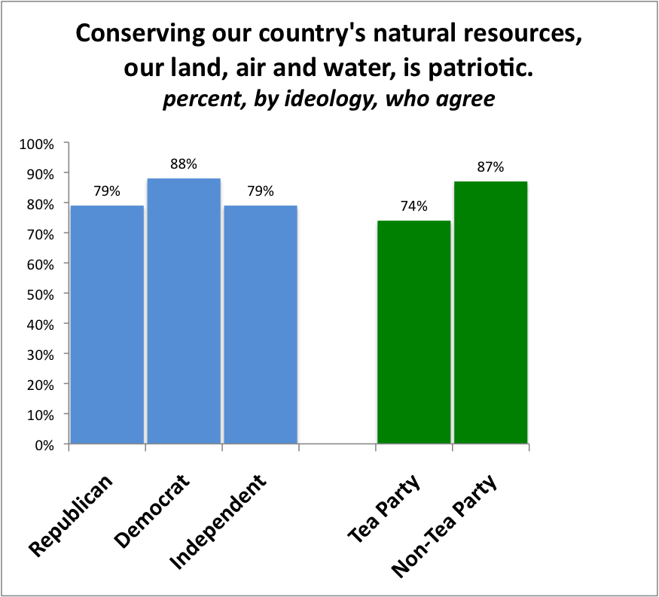
Conservation is Important
Unless otherwise noted, the findings in this section come from a 2012 national survey completed by a team of Republican and Democratic pollsters. As of 2017, this survey remains the most comprehensive sampling of Americans’ views of conservation.

Red or Blue, Green is Patriotic
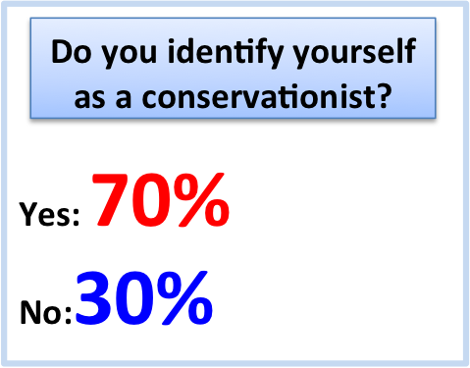
Eighty-two percent of voters think that conserving natural resources is patriotic. This holds true regardless of ideology or political affiliation. More than three-quarters (77%) believe that protecting and preserving the nation’s history and natural beauty through national parks, forests, and other public lands is one of the things the government does best.

Voters Identify as Conservationists
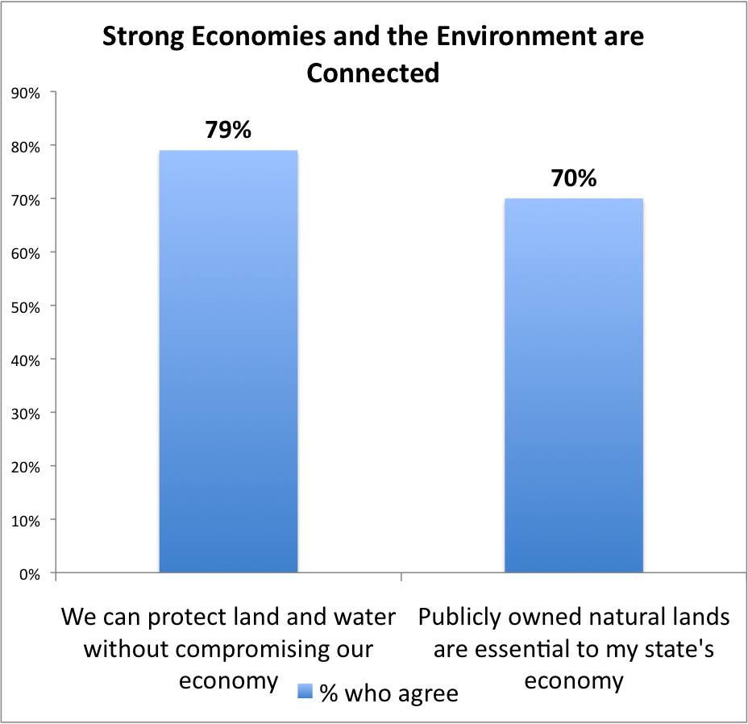
Voters identify themselves as conservationists and consider conservation in their voting decisions. Seven out of 10 respondents consider themselves “conservationists,” compared to 53% who label themselves “environmentalists.” Republicans are much more likely to use the “conservationist” label.

Conservation is Essential to the Economy
The majority of voters do not see protecting land and water to be at odds with protecting the economy. Almost eight out of 10 voters (79%) agreed with the statement “we can protect land and water without compromising our economy.” Seventy-seven percent believe that environmental protections have a positive or neutral impact on jobs, compared to 17% who believe that environmental protections hurt jobs. Seven in 10 voters said that public lands--state and national parks, forests, monuments, and wildlife areas--are essential to their state’s economy.

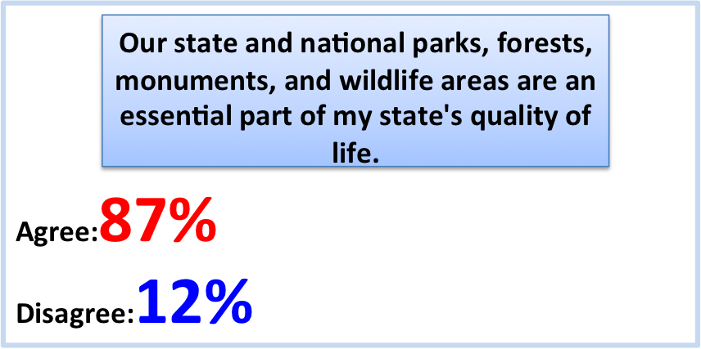
Conservation is Essential to Quality of Life
Almost 90% of voters believe that parks, forests, monuments, and wildlife areas are play an essential role in the quality of life in their state. More than half (53%) think that the best reason to conserve nature is because of its positive impact on human health and happiness, compared to 39% who prioritize conservation for nature’s sake.

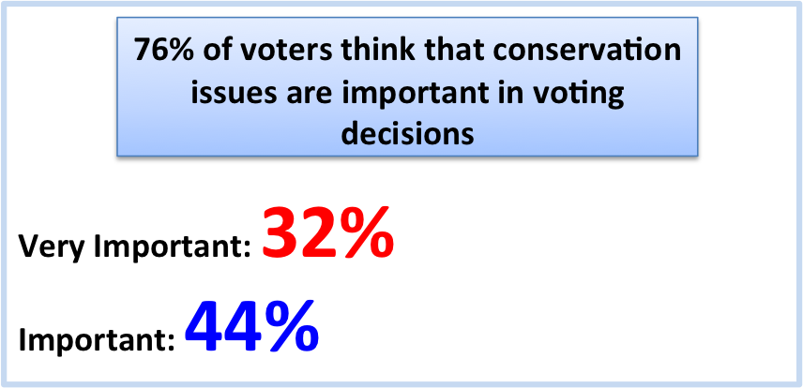
Conservation Concerns Affect Voting
Three-quarters (76%) of voters said that issues involving water quality (natural areas, lakes, rivers, or beaches), neighborhood parks, and wildlife habitat are important to them when deciding how to vote.
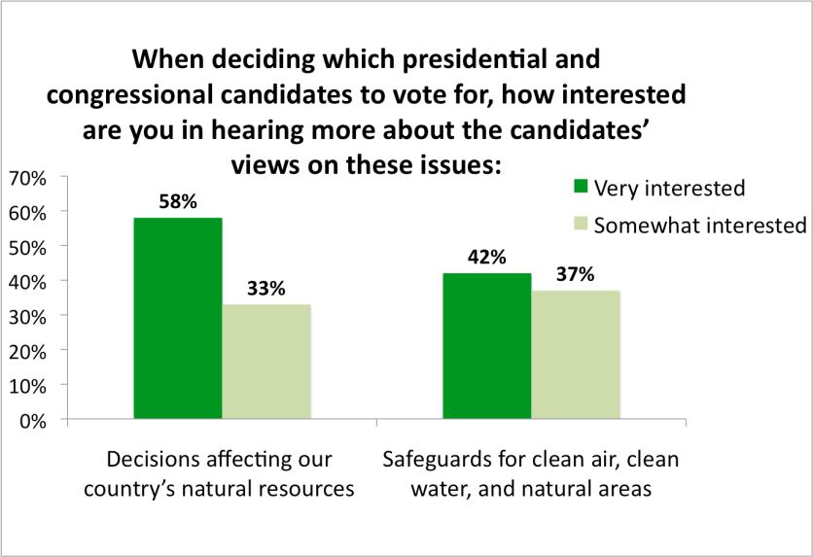
One-third (35%) of voters think their member of Congress places a lower priority on conservation than they do; only 16% think their representative values conservation more than they do.
In the survey, voters were asked several questions about the importance of conservation and environmental issues when voting. The majority said it was important to know presidential and congressional candidates’ views on natural resource issues, and natural resources were of similar importance to several hot-button topics. For example, 91% of voters were interested in the candidates’ views on decisions impacting natural resources, versus 90% on taxes. Seventy-nine percent were interested in positions on protecting clean air, clean water, and natural areas, contrasted with abortion (61%) and same sex marriage (52%).

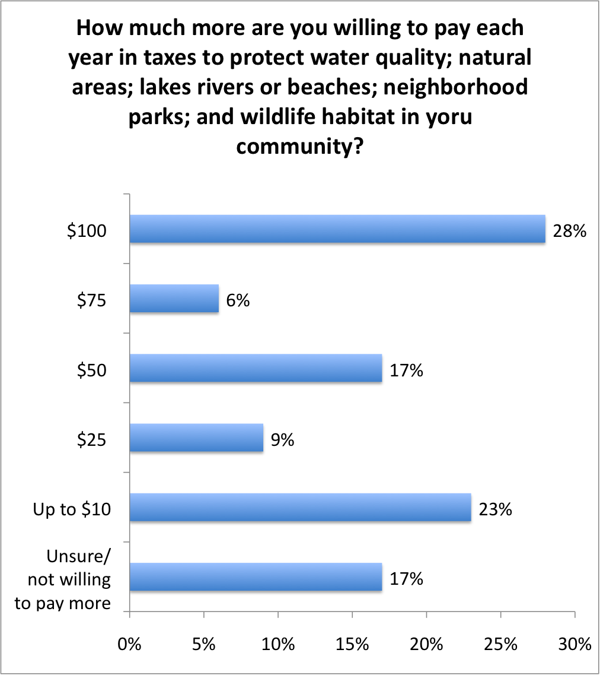
Voters are Willing to Pay More in Taxes to Support Conservation
A majority of voters support the idea of tax increases to fund conservation. Fifty-eight percent would support additional taxes at the local/state government level, and 56% at the federal government level. When presented with specific amounts 83% of voters say they are willing to pay at least something more. Those in a financial situation described as “comfortable” or “getting by” were much more likely to support tax increases than people who were “struggling.”
Broadly speaking, most voters (72%) think the government plays an essential role in protecting land, water, and wildlife, including 64% of conservative Republicans (who typically favor a limited federal government). Eighty-two percent of people think the government should lead conservation efforts for areas that cross state boundaries, such as mountain ranges, rivers, and wildlife habitats.

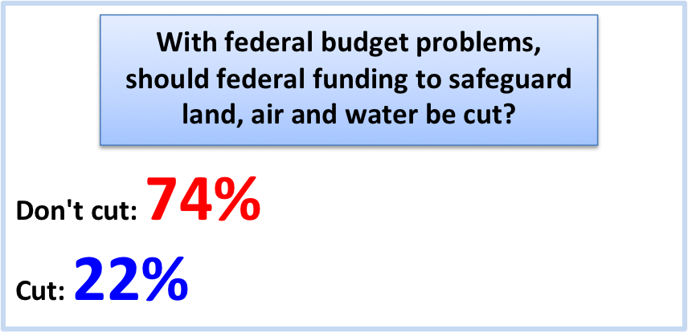
Voters Oppose Cuts to Conservation

Don’t Cut Federal Conservation Funding
Despite the challenging economic climate of 2012, three-quarters (74%) of voters opposed cuts to programs that safeguard land, air, and water.

Support the Land and Water Conservation Fund
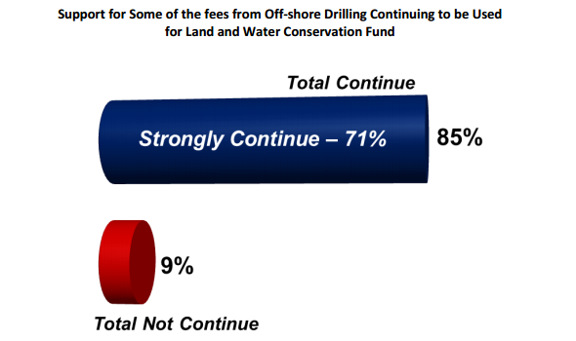
Created by Congress in 1965, the Land and Water Conservation Fund (LWCF) receives a small portion of the fees paid by oil and gas companies that drill in waters owned by the American people. LWCF helps create and protect national parks, areas around rivers and lakes, national forests, and national wildlife refuges, while also providing matching grants for state and local parks and recreation projects. It is the premier federal funding source for land conservation.
In a 2013 survey, 85% of voters preferred that the nation continue to invest in LWCF. Support for LWCF transcends party identity. Seventy-eight percent of Republicans, 84% of independents, and 93% of Democrats are in favor of funding LWCF.

Red, Blue, or Purple, States Support Green
Regardless of a state’s political leanings, its residents support conservation. Surveys in Montana, Maryland, and Pennsylvania demonstrate this.

Montana
Voters in Montana, which Gallup identifies as one of the most conservative states in America, value conservation. In a 2017 survey, nearly eight out of 10 (78%) voters identified themselves as conservationists. A majority of Montanan voters recognize the importance of maintaining public space for outdoor recreation: 92% support improving and repairing infrastructure in outdoor destinations, and 88% want to improve access to public lands.
Following the 2016 presidential election, a strong majority (63%) of Montana voters believe the Trump administration should emphasize protecting air and water resources while providing outdoor recreation opportunities on public lands.

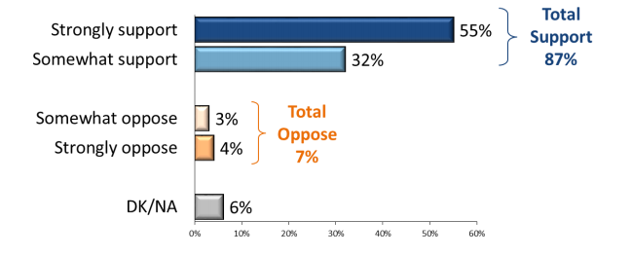
Maryland
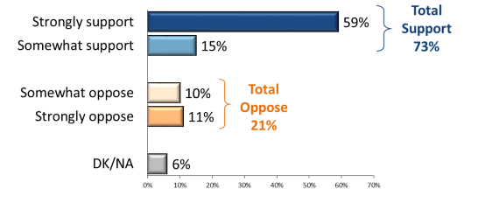
In Maryland, which Gallup identifies as one of the top-10 most liberal states, conservation is also a priority for voters. A 2016 survey found that support for the state’s land and water conservation program (Program Open Space) is nearly universal: 87% of voters said they support the program, including 55% who “strongly” support it. Support cuts across party lines, as 93% of Democrats, 90% of independents, and 77% of Republicans are in favor of the program.
Furthermore, voters express support for legislative measures to prevent the legislature from diverting money from Program Open Space to unrelated state programs. More than seven in 10 (73%) believe money should not be diverted from this statewide conservation program.

Pennsylvania
In the swing state of Pennsylvania, residents overwhelmingly support the use of state funds for conservation. In a 2015 poll, 90% of residents surveyed said they would support increasing state funds for land and water conservation, protection of historic sites, and farmland preservation.
Most (80%) were in favor of increased funds even if it cost the average household $10-20 more annually. Independents (86%) were the most willing, followed by Democrats (82%) and Republicans (75%).

State and Local Ballot Results Confirm Survey Findings
Each year, voters in various states, counties, and local municipalities face conservation funding ballot measures. Each year, these voters approve taxes and conservation spending in their communities. Between 1988 and 2017, there were 2,613 conservation funding measures on local and statewide ballots; 1,973 (75%) passed, allocating more than $75 billion for conservation.
For more information on these votes, see the Trust for Public Land’s LandVote database.

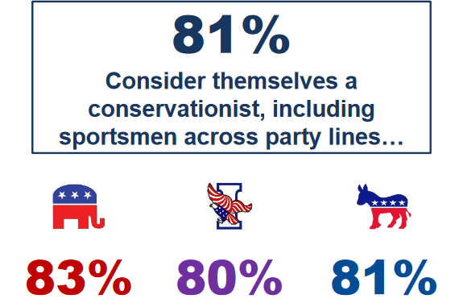
Views of Hunters and Anglers
Anglers and hunters express resounding support for conservation. This section cites data from a 2017 national survey of 1,000 voters who identify as hunters and/or anglers.

Sportspeople Identify Themselves as Conservationists
Nearly four in ten respondents (37%) identify as Republican, 36% as independent, and 20% as Democratic. A third live in rural areas, 30% in the suburbs, and 17% in urban areas.
Most (81%) identified themselves as conservationists, including 83% of Republicans, 81% of Democrats, and 80% of independents.

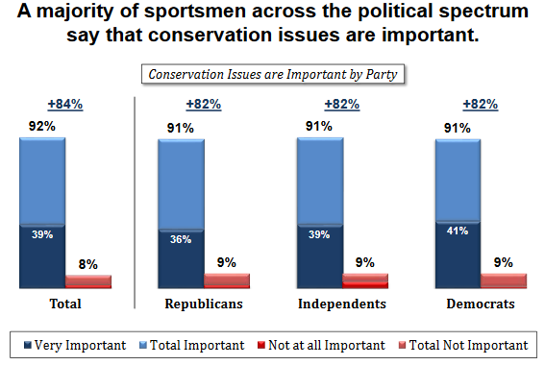
Sportspeople Prioritize Conservation
Nearly all voters (97%) agree that protecting public lands for future generations is important. Eighty-three percent, including 90% of Clinton voters and 73% of Trump voters, say this is “very important.” Sportspeople are concerned about the future: 85% worry that “outdoor traditions and recreation opportunities are being lost for the next generation,” with 52% “strongly” agreeing. Ninety-two percent say that conservation issues are important in their support for an elected official; 39% say it is the primary factor.

Sportspeople Support Conservation Funding
A vast majority (87% total) oppose cuts to conservation programs in the federal budget, despite budget difficulties; 59% strongly oppose cuts. More than two-thirds (67%) oppose selling public lands to reduce the federal budget deficit.
Nearly eight in 10 (79%) support using offshore oil and gas drilling fees for conservation and outdoor recreation. Most (75%) support providing financial incentives for farmers to conserve land.
Overall, 92% believe public lands make positive contributions to the economy; 58% strongly believe this.

National Parks

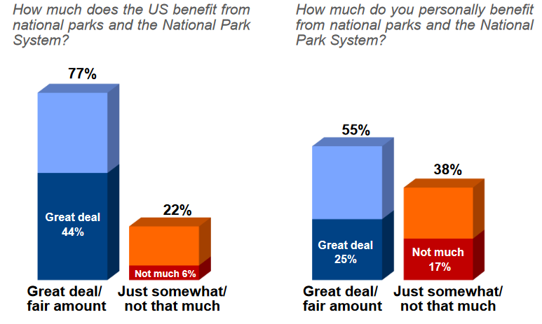
Concern for Parks Transcends Politics
Protecting national parks is important to voters, regardless of political ideology. In a 2016 poll, 77% of respondents said that the United States benefits “a great deal” or “fair amount” from the National Park System, and 55% said they personally benefitted. Sixty-five percent said that strengthening the National Park System should be an important priority.

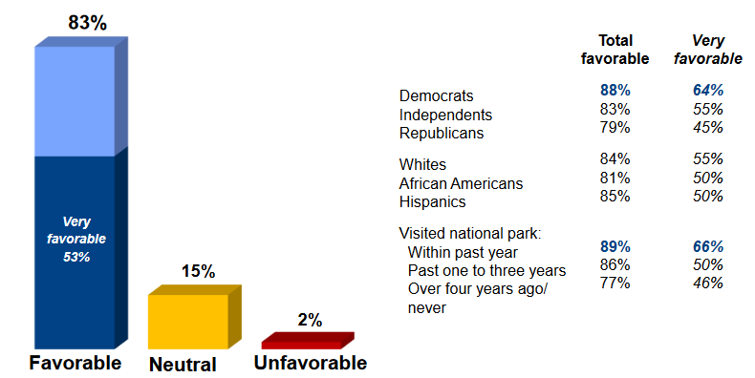
Pro-Park Candidates are Viewed Favorably
The poll found that—across party lines—voters think highly of pro-national park candidates. The vast majority of Democrats (88%), independents (83%), and Republicans (79%) said they would have a favorable reaction if their representative in Congress supported policies to protect and strengthen national parks.

Increase or Maintain Government Support for Parks
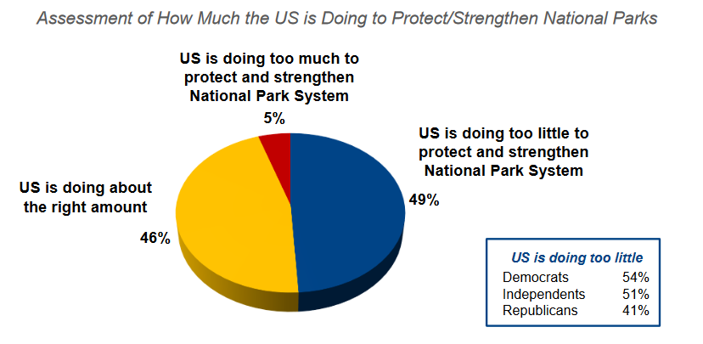
The same poll showed that nearly half of voters (49%) think the federal government is doing too little to protect and strengthen national parks. Another 46% think the government is doing the right amount. Only 6% say the government is doing too much.
A majority of Democrats and independents (54% and 51%, respectively), and 41% of Republicans, believe the government should do more to bolster the National Park System.

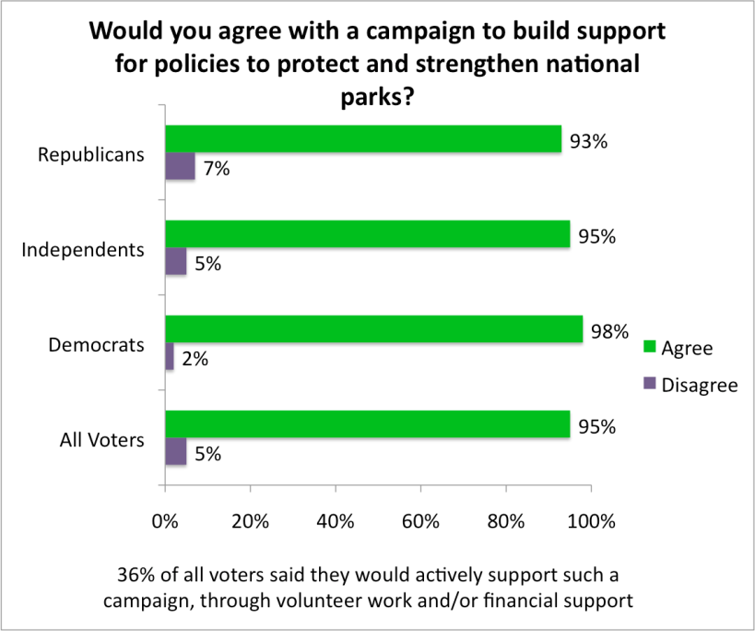
Campaign to Protect and Strengthen Parks
When it comes to political campaigns, it’s not easy to find an issue that unites more than nine out of 10 voters. Yet a campaign in support of national parks could do just that.
In an earlier 2012 poll, voters were asked if they would support a national campaign to build support for policies that protect and strengthen national parks. Not only would 95% of people support this campaign, but 36% would actively contribute through volunteer work and/or financial contributions. Only 5% of voters would disagree with the campaign’s goals altogether.

Wildlife Conservation
Over the years, voters have consistently expressed support for efforts to conserve wildlife. In a 2015 poll, 90% of voters said they support the Endangered Species Act, the federal law that protects species in danger of extinction, compared to 7% in opposition. Liberals (96%), moderates (94%), and conservatives (82%) from all regions of the country recognize the importance of safeguarding vulnerable wildlife. In Gallup polls on environmental topics, people report that extinction of plant and animal species is one of the most concerning issues. In 2017, 72% said they worry “a great deal” or “fair amount” about extinction of plant and animal species.

Resources at ConservationTools.org
To find related resources, see the right column of the on-line edition at http://conservationtools.org/guides/111

***

Comments
Help improve the next edition of this guide. Email your suggestions to the Pennsylvania Land Trust Association at aloza@conserveland.org. Thank you.

Acknowledgements
Elana Richman compiled and Andrew M. Loza edited the first edition of this guide (2013). Nate Lotze updated the contents for the second edition (2017).
The Pennsylvania Land Trust Association published this guide with support from the William Penn Foundation and the Community Conservation Partnerships Program, Environmental Stewardship Fund, under the administration of the Pennsylvania Department of Conservation and Natural Resources, Bureau of Recreation and Conservation.

© 2017, 2013 Pennsylvania Land Trust Association
Text may be excerpted and reproduced with acknowledgement of ConservationTools.org and the Pennsylvania Land Trust Association

Environmental Protection Survey. Pew Research Center (2016). Telephone survey of 2,254 registered voters nationwide from March 17-27, 2016.
National Survey: American Voters View Conservation as Patriotic. Conducted by the bipartisan team of FM3 (Democratic) and Public Opinion Strategies (Republican) for The Nature Conservancy (2012). Telephone survey of 800 registered voters nationwide from June 16-19, 2012.
American Voters View Conservation as a Smart Investment. Conducted by the bipartisan team of FM3 (Democratic) and Public Opinion Strategies (Republican) for The Nature Conservancy (2013). Telephone survey of 700 registered voters nationwide from September 23-26, 2013.
State of the States. Gallup (2016). Data from Gallup Daily tracking survey, which polls 1,000 adults nationwide each day, 350 days per year.
Conservation in the West: Montana. Conducted by the bipartisan team of FM3 (Democratic) and Public Opinion Strategies (Republican) for the Colorado College State of the Rockies project (2017). Telephone survey of 400 registered voters in Montana from January 4-10, 2017.
Survey of Maryland Voters on Program Open Space. Conducted by the bipartisan team of FM3 (Democratic) and Public Opinion Strategies (Republican) for Partners for Open Space (2016). Telephone survey of 704 registered voters in Maryland from January 31-February 2, 2016.
Pennsylvania Statewide Public Opinion Survey. Conducted by the Center for Survey Research at Penn State Harrisburg for The Nature Conservancy and The Trust for Public Land (2015). Telephone of 601 adult Pennsylvania residents from March 4-April 15, 2015.
LandVote Database. The Trust for Public Land, www.landvote.org
National Sportsmen’s Survey. Conducted by Public Opinion Strategies for the Theodore Roosevelt Conservation Partnership (2017). Telephone and internet survey of registered voters nationwide who identify as hunters and/or anglers from May 1-8, 2017.
Public Opinion on National Parks. Conducted by Hart Research for the Center for American Progress (2016). Telephone survey of 1,024 registered voters nationwide from January 11-17, 2016.
Strong Bipartisan Support for National Parks. Conducted by Hart Research for the National Park Conservation Association and National Park Hospitality Association (2012). Telephone survey of 1,004 registered voters nationwide from June 12-17, 2012.
National Consensus on the Endangered Species Act. Conducted by Tulchin Research for Defenders of Wildlife and Earthjustice (2015). Online survey of 600 registered voters nationwide from June 25-29, 2015.
In Depth Topics: Environment. Gallup. http://www.gallup.com/poll/1615/environment.aspx

