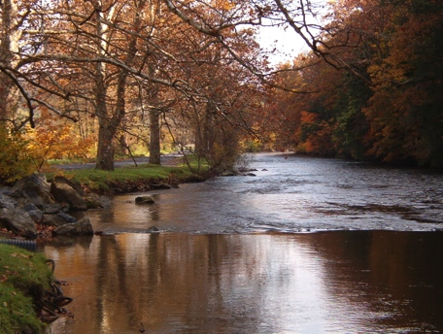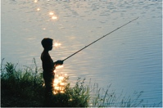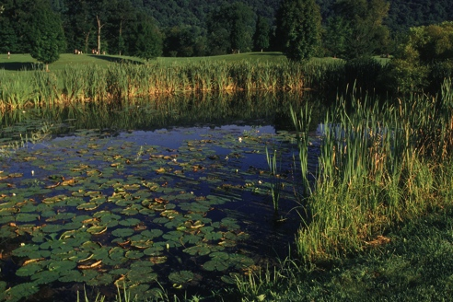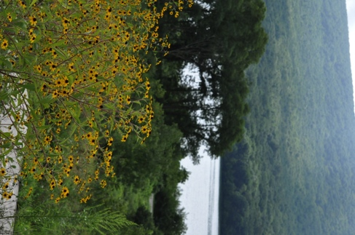

Funding

Conservation Easement Stewardship

The subdivision of a portion of the conserved property, the building of a house or some other major change to the land, if allowed by the conservation easement, will dramatically increase the land trust’s long-term stewardship liability. Two sets of landowners, for example, doubles the potential for a violation of the easement’s terms. Rather than require you to cover these added stewardship costs up front, the land trust can arrange with you for a “conditional payment” – a payment that only comes due if you take an action that increases the land trust’s stewardship liability

The payments you make as required by your stewardship funding arrangement may be tax deductible for federal tax purposes. Since the land trust can not provide tax advice, you should work with your tax advisor to establish certainty.

Payments made by future landowners are not tax deductible.

## Are payments tax deductible?

The stewardship funding arrangements presented here can be customized to address the specifics of your particular conservation project. Please do not hesitate to ask us questions or do your own research.

[ConservationTools.org](http://conservationtools.org) provides the guide *Stewardship Funding Arrangements* and other landowner resources.

## We will work with you to find a winning funding arrangement.

### Some stewardship expenses only occur if you exercise a reserved right.

Conservation of your land begins with the recording of the easement document

[INSERT LAND TRUST NAME]

[INSERT ADDRESS and PHONE #]  
[INSERT URL and EMAIL]

*Option B*

**Single deferred payment or installment payments made by you**

You may arrange to defer all or a portion of the needed stewardship contribution until such time or times that you are best prepared to make the payments.

*Option C*

**Payment obligations spread out to future owners of your land**

You may arrange for one or more deferred payments to be made by the people who follow you in ownership of the land.

*Option D*

**Regular payments**

Rather than a fixed number of payments, you may instead arrange for ongoing payments at regular time intervals. You could make payments annually (or at some other interval), but then, when you convey your land to someone else, that person takes over the payments. If more convenient, the arrangement can allow you to defer making the payments until you sell your property.

*Option E*

**Payments due with each property transfer**

You may arrange that a payment comes due with each transfer of the property.

# Stewardship Funding Arrangements: A menu of options from which to choose

When our land trust accepts a grant of conservation easement, it accepts the responsibility to uphold the easement’s conservation objectives in perpetuity. While the land trust welcomes this obligation – after all, it is what we do – we recognize that the acceptance of an easement comes with ongoing costs of monitoring, outreach and enforcement – costs that never end. We take seriously the need to ensure that we always have the money to uphold our easements. This is why we ask the landowners intending to grant a conservation easement to make a financial commitment to support long-term stewardship.

Easements create obligations.

*The land trust, based on its experiences and those of other land trusts, will calculate the amount of money it will need to reasonably assure that it can meet its stewardship obligations in perpetuity. Using these calculations, the land trust will work with you to identify a funding arrangement that respects both your financial concerns and the need to ensure that the land trust can responsibly meet its stewardship obligation. Options, which may be used in combination, include:*

*Option A*

**Contribution at easement closing**

Some owners have both the means and the desire to fully fund the land trust’s stewardship needs with a single upfront contribution.